

*Draft*

**VACCINE LOGISTICS**

**MANAGEMENT INFORMATION SYSTEM**

User Manual (Cold Chain)

September 2014



**Table of Contents**

[Revision History 6](#_Toc402260328)

[List of Acronyms 7](#_Toc402260329)

[Overview 11](#_Toc402260330)

[Background 11](#_Toc402260331)

[Overview of Web-based LMIS 13](#_Toc402260332)

[**Vaccine Logistics Management Information System (vLMIS)** 15](#_Toc402260333)

[**vLMIS Features** 17](#_Toc402260334)

[**Assumptions** 18](#_Toc402260335)

[**System Requirements** 18](#_Toc402260336)

[**Browser Support** 18](#_Toc402260337)

[Users & User Roles 19](#_Toc402260338)

[**Anonymous/Guest User** 19](#_Toc402260339)

[**Authenticated Users** 20](#_Toc402260340)

[**EPI User – National** 20](#_Toc402260341)

[**EPI User – Provincial** 21](#_Toc402260342)

[**EPI User – District** 22](#_Toc402260343)

[**EPI User - Tehsil** 24](#_Toc402260344)

[**EPI User - UC** 25](#_Toc402260345)

[**Policy User (National, Provincial and District)** 26](#_Toc402260346)

[**Campaign User (National)** 26](#_Toc402260347)

[**Campaign User (Provincial)** 27](#_Toc402260348)

[**Campaign User (District)** 27](#_Toc402260349)

[**CCEM Operators (National, Provincial, District)** 28](#_Toc402260350)

[**Geographical Areas** 29](#_Toc402260351)

[Step-by-Step 30](#_Toc402260352)

[vLMIS Homepage 31](#_Toc402260353)

[**Homepage Menu** 32](#_Toc402260354)

[**Contact Us Tab** 32](#_Toc402260355)

[**Frequently Asked Questions Tab** 32](#_Toc402260356)

[**Changing Your Password** 35](#_Toc402260357)

[**Forgot Password** 36](#_Toc402260358)

[**Logging Out** 37](#_Toc402260359)

[CCEM Reports and Graphs 39](#_Toc402260360)

[Overview 39](#_Toc402260361)

[CCEM Reports 40](#_Toc402260362)

[**Storage** 41](#_Toc402260363)

[**Inventory** 47](#_Toc402260364)

[**Refrigerators Freezers** 49](#_Toc402260365)

[**Cold Rooms** 58](#_Toc402260366)

[**Cold Boxes** 61](#_Toc402260367)

[**Generators and Stabilizers** 64](#_Toc402260368)

[CCEM Graphs 67](#_Toc402260369)

[**Storage** 68](#_Toc402260370)

[**Refrigerator Freezers** 72](#_Toc402260371)

[**Cold Boxes** 76](#_Toc402260372)

[**Generators Stabilizers** 79](#_Toc402260373)

[Cold-chain 82](#_Toc402260374)

[Cold Chain Logistics 82](#_Toc402260375)

[**Why is Cold Chain Logistics important?** 83](#_Toc402260376)

[**Environmental factors** 84](#_Toc402260377)

[**Cold Chain Module in vLMIS** 85](#_Toc402260378)

[**Cold Chain Storage** 86](#_Toc402260379)

[**Recommendations** 87](#_Toc402260380)

[CCEM 88](#_Toc402260381)

[**National CCEM Operator** 90](#_Toc402260382)

[**Dashboard** 92](#_Toc402260383)

[**Cold Chain** 97](#_Toc402260384)

[**Maps** 130](#_Toc402260385)

[**CCEM Reports** 132](#_Toc402260386)

[**CCEM Graphs** 132](#_Toc402260387)

[**Provincial CCEM Operator** 133](#_Toc402260388)

[**Dashboard** 135](#_Toc402260389)

[**Cold Chain** 140](#_Toc402260390)

[**Maps** 172](#_Toc402260391)

[**CCEM Reports** 174](#_Toc402260392)

[**CCEM Graphs** 174](#_Toc402260393)

[**District CCEM Operator** 175](#_Toc402260394)

[**Dashboard** 177](#_Toc402260395)

[**Cold Chain** 182](#_Toc402260396)

[**Maps** 214](#_Toc402260397)

[**CCEM Reports** 216](#_Toc402260398)

[**CCEM Graphs** 216](#_Toc402260399)

# Revision History

|  |  |  |  |
| --- | --- | --- | --- |
| **Name** | **Date** | **Reason For Changes** | **Version** |
| Pakistan Field Office | 30 August 2014 | First Draft | 1.0 |
| Pakistan Field Office | 15 September 2014 | Additions to CCEM Module | 1.1 |

# List of Acronyms

|  |  |
| --- | --- |
| AJK | Azad Jammu & Kashmir |
| AMC | Average Monthly Consumption |
| BCG | Bacillus Calmette–Guérin Vaccine |
| BHU | Basic Health Unit |
| bOPV | Bivalent oral polio vaccine |
| CCEM | Cold Chain Equipment Manager |
| DHCSO | District Health Communication Support Officer |
| DHQ | District Head Quarter Hospital |
| DMS | Deputy Medical Superintendent |
| DSV | District Superintendent Vaccination |
| EDO | Executive District Officer |
| EPI | Expanded Program on Immunization |
| FATA | Federally Administered Tribal Areas |
| GAVI | Global Alliance for Vaccines and Immunization |
| GOP | Government of Pakistan |
| HF | Health Facility |
| ICT | Information Communications Technologies |
| IM | Inventory Management |
| IT | Information Technology |
| JSI | John Snow, Inc. |
| KP | Khyber Pakhtunkhwa |
| LMIS | Logistics Management Information System |
| LQAS | Lot Quality Assurance Sampling |
| MIS | Management Information System |
| MIPC | Ministry of Inter Provincial Coordination |
| MNHRC | Ministry of National Health Services, Regulation and Coordination |
| NID | National Immunization Days |
| OPV | Oral Polio Vaccine |
| PEI | Polio Eradication Initiative |
| PPHI | Peoples Primary Healthcare Initiative |
| SDP | Service Delivery Point |
| SIADs | Short Interval Additional Dose Strategy |
| SIAs | Supplementary Immunization Activities |
| SOP | Standard Operating Procedure |
| Syr. | Syringe |
| THO | Taluka Health Officer |
| THQ | Tehsil Head Quarter Hospital |
| tOPV | Trivalent oral polio vaccine |
| TSI | Tehsil Sanitary Inspector |
| UC | Union Council |
| UNICEF | United Nations Children's Fund |
| UPEC | Union Council Polio Eradication Committee |
| USAID | United States Agency for International Development |
| WHO | World Health Organization |

|  |  |
| --- | --- |
| Overview | **1** |
| With Vaccine Logistics Management Information System | |

The *Vaccine Logistics Management Information System User Guide* provides step-by-step instructions that help you get started with Vaccine Logistics Management Information System (vLMIS) functions and features and provides guidelines on managing relevant Vaccines Logistics data using the Vaccine Logistics Management Information System accounts.

This guide is organized according to the logical flow of Vaccine Logistics Management Information System features and describes tasks in the same order you can use while working with the product.

|  |  |
| --- | --- |
| *C:\Users\isbah.zulfiqar\Desktop\1382615592_file_edit.png* | Before You Begin...  It is recommended to have a working internet connection for web-access to the application in order to review the product side-by-side when reading this manual. |

# Background

In July 2011, Pakistan’s first web-based Logistics Management Information System (web-LMIS) for contraceptive products was launched, which is currently in use in all 143 districts. Following the success of the Logistics Management Information System for Contraceptives, the design of a   
web-based Tuberculosis Drug Management Information System (TBDMIS) was rolled-out in   
March, 2013 and now, Vaccine Logistics Management Information System has also been incorporated into the current Logistics Management Information System in 54 priority districts in Pakistan, thus making the web-based Pakistan Logistics Management Information System as one automated logistics management information system for all health commodities, i.e., Contraceptives, Tuberculosis and Vaccines.

The Vaccine Logistics Management Information System (vLMIS) is designed to replace the current manual Vaccine Logistics Record keeping system and therefore considers the current system’s strengths and challenges.

Among the strengths in the current vaccine logistics data is that key data items are collected, such as consumption, stock balance, and storage capacity. Some logistics-related key performance indicators have been defined and are tracked. Data is collected routinely and there is a defined process flow for reporting up the system. There are established forms and spreadsheets used to collect data, and a vaccine stock management software solution used at the National EPI Store. There is a culture of compiling and analyzing data for logistics decision making. The data on existing cold chain equipment (age, type, capacity, operability) in the national cold chain inventory as well as facility profile data has also been collected to help identify gaps in the cold chain storage capacity and functionality that need to be addressed.

However, there are significant challenges in the collection, use and management of vaccine logistics data. Routine reporting of logistics data is impeded by poor accuracy and timeliness of the reports and inadequate supervision and feedback on reporting. Wastage (due to open vial) data are under-reported and poorly tracked. Resupply is calculated based on demographic based targets (using population figures that are outdated) rather than consumption data, and stock balance is not always factored into resupply decisions. Because data is not available in real-time electronic form to all stakeholders, there is very limited visibility in the pipeline below the national level.

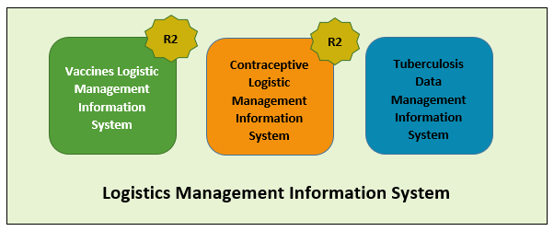

# Overview of Web-based LMIS

Pakistan Web-based LMIS provides transparency to all stakeholders based on user rights, is easy to use, and integrates both routine and special immunization campaign vaccine logistics data. Standardized reporting forms and Data triangulation is implemented to validate data and improve visibility in wastage rates.

Resupply quantities for routine EPI are calculated based on average monthly consumption and stock balances, and wastage rates are calculated automatically. The use of stock balance, consumption and issued data, losses and adjustments are also collected.

New routine reporting forms are aquatically printed using vLMIS inventory management module in order to collect data from service delivery points, along with vaccine logistics standard operating procedures (SOPs) for each level of the supply chain.

The Vaccine Logistics Management Information System contains the following features:

1. A module for Vaccine reporting in the centralized web-accessible data repository of LMIS to report data from data providers. Data Providers can perform monthly data entry. This also includes being able to generate reports for themselves.
2. The data provided by different geographical levels tracks vaccines in different data entry forms. The Stock Issue and Receive Data, (National, Provincial, Divisional, District, Tehsil) users will enter vaccines logistics data with batch and expiry information, while Monthly Consumption data (Tehsil and Union Council level) users will report data without batch. Wastage will be calculated automatically with the help of consumed and unused vial information.
3. The cold-chain inventory and use is tracked in vLMIS. This module is capable of entering new cold chain assets as well as its current operational status. Each month, along with other logistics data, users will update the operational status of their cold chain assets.
4. The Administrator will manage vLMIS and create all of the necessary data in order to assist users to continue to provide and review logistics data.
5. Data Reviewers can access vLMIS using the ‘guest’ user account and get reports about the country’s provinces and districts to help them in logistical decision-making regarding supply chain management in their assigned districts.

## **Vaccine Logistics Management Information System (vLMIS)**

The web-based Vaccine Logistics Management Information System has been designed to help plan and manage the immunization resources and ensure that vaccines are always available to meet demand at the right time, to the right place, at the right cost, in the right condition of the right product in the right amount – No matter where they live.

|  |
| --- |
| http://www.mchip.net/sites/default/files/India%20mom%20and%20boy%20saveJPG_0.JPG**Millions of people are alive today because of immunization programs** from diseases such as diarrhea, pneumonia, polio, measles, tetanus, and other life-threatening illnesses. The current immunization programs save more than **2.5 million lives each year**; however, **24 million children still do not get** the complete routine immunizations scheduled for their first year of life, because of weak health systems and difficulties with delivering vaccines to remote locations on time. |

The web-based Vaccine Logistics Management Information System (vLMIS) is an extension of the Logistics Management Information System (LMIS) and is designed to replace the current paper-based logistics information system that is being used for managing the vaccine distribution and logistics.

The Vaccine Logistics Management Information System introduces systematic vaccine product management and create sustainable dependencies among different vaccine procurement procedures and geographical level operations.

The web-based Vaccine Logistics Management Information System (vLMIS) is easy to use and contextualized to fit local stakeholder’s structure and the devolution of health and population programs to provincial governments. The system brings in district and EPI-level reporting by aggregating facility-level data through paper-based reports. With a unified system for reporting and requisitioning, the vLMIS system is able to integrate information from all levels and sectors. The web-based vLMIS can be accessed at <http://lmis.gov.pk>.

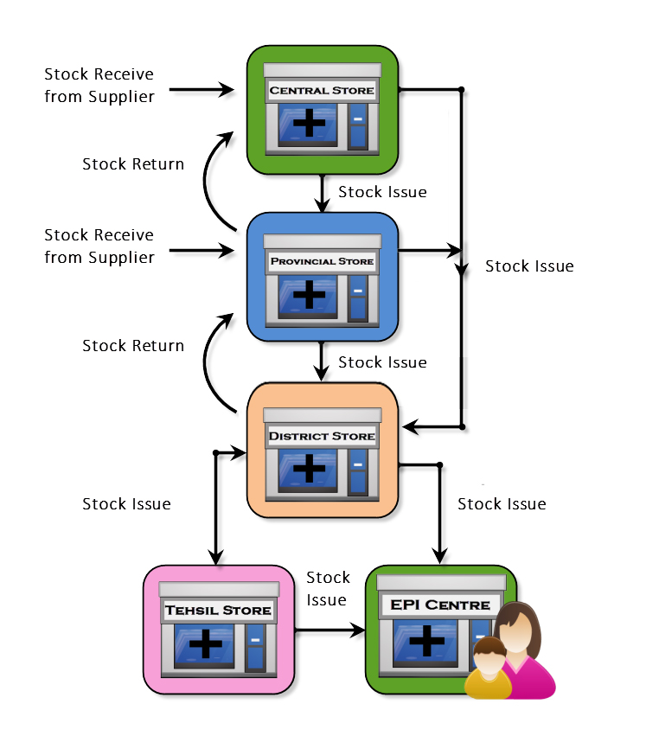

**The Vaccine Supply Chain**

## **vLMIS Features**

Vaccine Logistics Management Information System provides the following functions and features:

|  |  |
| --- | --- |
| Role-Based Access for Users  Users are authenticated based on their geographical levels and the roles that are associated with them. | Inventory Management  Stock Issued, Received, and adjustments are recorded on transaction basis in vLMIS by the EPI Store Users. |
| Automated Stock Transactions  Stock transactions are updated in the system and calculated automatically for transfers and adjustments using vLMIS for better management of inventory. | Cold-Chain Assets  The details of Cold-chain assets, their location, status and capacity is tracked in vLMIS for maintaining the cold-chain of immunization vaccines. |
| Batch Management  vLMIS offers batch management in order to maintain the First expiry first out process for vaccine during stock issue. | Consumption Reporting  Service delivery point data will be collected and recorded daily and compiled and reported online monthly using vLMIS. |
| Data Reports  Performance reports enable you to view the monthly reporting performance country-wide. | Graph and Maps  Graphs and maps enable you to view and compare different Indicators and view performance and comparison reports over time. |

## **Assumptions**

This user guide assumes that you already have Vaccine Logistics Management Information System accounts as per your geographical level and role. This user guide also assumes that you are familiar with basic web-application account login procedures.

## **System Requirements**

The Vaccines Logistics Management Information System is accessible from any Desktop PC, Mac, or Linux computer with Internet access and a supported Web-browser.

## **Browser Support**

The following browsers and later versions fully support vLMIS standard view:

* Mozilla Firefox (Windows, Mac, Linux)
* Google Chrome (Windows, Mac, Linux)
* Netscape (Windows, Mac, Linux)
* Safari (Mac)
* Internet Explorer 9 and above (Windows)

|  |  |
| --- | --- |
| Users & User Roles | **2** |
| of Vaccines Logistics Management Information System | |

This section explains the users and their roles in Vaccine Logistics Management Information System. The Vaccine Logistics Management Information System Users are basically store operators that manage and record the inventory and stock transactions. Each geographical level entails different user roles associated with their warehouse/store operations.

## **Anonymous/Guest User**

The Anonymous or Guest user can be any web user with the following capabilities:

|  |  |
| --- | --- |
| **Feature** | **Responsibilities** |
| **Reports** | View national and provincial level geographical and periodic logistics information in tabular formats. |
| **CCEM Reports** | View geographical and periodic CCEM information in tabular formats. |
| **Campaign Reports** | View geographical and periodic campaign information in tabular formats. |

## **Authenticated Users**

The Authenticated users can log in to vLMIS and perform assigned functions. Each user is assigned responsibilities based on the role and geographical level.

### **EPI User – National**

|  |  |
| --- | --- |
| **Feature** | **Responsibilities** |
| **Inventory Management** | Receive stock from provincial warehouses.  Receive stock from supplier and create placement vouchers.  Search for received stock.  Issue stock to other warehouses  (Province, District and Field stores) and  create pick order forms.  Search for issued stock.  Manage Batches.  Add placement locations for stock.  Transfer stock to other locations. |
| **Stock Adjustments** | Manage adjustments.  Search for adjustments |
| **Manage Gate Pass** | Issue a new gate pass.  View the list of issued gate passes. |
| **CCEM** | Manage Cold Chain Assets.  Asset Working Status update |
| **Reports** | View geographical and periodic logistics information in tabular formats. |
| **CCEM Reports** | View geographical and periodic CCEM information in tabular formats. |
| **IM Graphs** | View geographical and periodic inventory management information in graphical formats. |
| **CCEM Graphs** | View geographical and periodic cold-chain equipment management information in graphical formats. |
| **Maps** | View geographical and periodic logistics information in map formats. |
| **Campaign Reports** | View geographical and periodic campaign information in tabular formats. |
| **Others** | Change account password. |

### **EPI User – Provincial**

|  |  |
| --- | --- |
| **Feature** | **Responsibilities** |
| **Inventory Management** | Receive stock from National warehouse.  Receive stock from supplier and create placement vouchers.  Search for received stock.  Issue stock to other warehouses  (National, Province, Division, District stores) and  create pick order forms.  Search for issued stock.  Manage Batches.  Add placement locations for stock.  Transfer stock to other locations. |
| **Stock Adjustments** | Add adjustments.  Search for adjustments |
| **Manage Gate Pass** | Issue a new gate pass.  View the list of issued gate passes. |
| **CCEM** | Manage Cold Chain Assets.  Asset Working Status update |
| **Reports** | View geographical and periodic logistics information in tabular formats. |
| **Maps** | View geographical and periodic logistics information in map formats. |
| **CCEM Reports** | View geographical and periodic CCEM information in tabular formats. |
| **IM Graphs** | View geographical and periodic inventory management information in graphical formats. |
| **CCEM Graphs** | View geographical and periodic cold-chain equipment management information in graphical formats. |
| **Campaign Reports** | View geographical and periodic campaign information in tabular formats. |
| **Others** | Change account password. |

### **EPI User – District**

|  |  |
| --- | --- |
| **Feature** | **Responsibilities** |
| **Inventory Management** | Receive stock from National / Provincial warehouse.  Search for received stock.  Issue stock to other warehouses  (National, Province, Division, District stores) and  create pick order forms.  Search for issued stock.  Manage Batches.  Add placement locations for stock.  Transfer stock to other locations. |
| **Stock Adjustments** | Add adjustments.  Search for adjustments |
| **Manage Gate Pass** | Issue a new gate pass.  View the list of issued gate passes. |
| **CCEM** | Manage Cold Chain Assets.  Asset Working Status update |
| **Reports** | View geographical and periodic logistics information in tabular formats. |
| **Maps** | View geographical and periodic logistics information in map formats. |
| **CCEM Reports** | View geographical and periodic CCEM information in tabular formats. |
| **IM Graphs** | View geographical and periodic inventory management information in graphical formats. |
| **CCEM Graphs** | View geographical and periodic cold-chain equipment management information in graphical formats. |
| **Campaign Reports** | View geographical and periodic campaign information in tabular formats. |
| **vLMIS Explorer** | View previously submitted Monthly Report data for the selected warehouse and the specified month and year. |
| **Others** | Change account password. |

### **EPI User - Tehsil**

|  |  |
| --- | --- |
| **Feature** | **Responsibilities** |
| **Inventory Management** | Receive stock from Provincial / District warehouse.  Search for received stock.  Issue stock to other warehouses  (National, Province, Division, District stores) and  create pick order forms.  Search for issued stock.  Manage Batches.  Add placement locations for stock.  Transfer stock to other locations. |
| **Stock Adjustments** | Add adjustments.  Search for adjustments |
| **Manage Gate Pass** | Issue a new gate pass.  View the list of issued gate passes. |
| **CCEM** | Manage Cold Chain Assets.  Asset Working Status update |
| **Reports** | View geographical and periodic logistics information in tabular formats. |
| **Maps** | View geographical and periodic logistics information in map formats. |
| **CCEM Reports** | View geographical and periodic CCEM information in tabular formats. |
| **IM Graphs** | View geographical and periodic inventory management information in graphical formats. |
| **CCEM Graphs** | View geographical and periodic cold-chain equipment management information in graphical formats. |
| **Monthly Stock Consumption** | Enter/View monthly reported data of products for the assigned Warehouse/Store. |
| **Others** | Change account password. |

### **EPI User - UC**

|  |  |
| --- | --- |
| **Feature** | **Responsibilities** |
| **Monthly Stock Consumption** | Enter/View monthly reported data of products for the assigned Warehouse/Store. |
| **CCEM** | Cold Chain Status Update. |
| **Reports** | View geographical and periodic logistics information in tabular formats. |
| **CCEM Reports** | View geographical and periodic CCEM information in tabular formats. |
| **CCEM Graphs** | View geographical and periodic cold-chain equipment management information in graphical formats. |
| **Campaign Reports** | View geographical and periodic campaign information in tabular formats. |
| **Others** | Change account password. |

### **Policy User (National, Provincial and District)**

|  |  |
| --- | --- |
| **Feature** | **Responsibilities** |
| **Reports** | View geographical and periodic logistics information in tabular formats. |
| **CCEM Reports** | View geographical and periodic CCEM information in tabular formats. |
| **CCEM Graphs** | View geographical and periodic cold-chain equipment management information in graphical formats. |
| **IM Graphs** | View geographical and periodic inventory management information in graphical formats. |
| **Campaign Reports** | View geographical and periodic campaign information in tabular formats. |
| **Others** | Change account password. |

### **Campaign User (National)**

|  |  |
| --- | --- |
| **Feature** | **Responsibilities** |
| **Campaigns** | Add Campaign  Search Campaigns  Data Entry History  Campaigns Target  LQAS Data Entry |
| **Campaign Reports** | View geographical and periodic campaign information in tabular formats. |
| **Others** | Change account password. |

### **Campaign User (Provincial)**

|  |  |
| --- | --- |
| **Feature** | **Responsibilities** |
| **Campaigns** | Add Campaign  Search Campaigns  Data Entry History  Campaigns Target  LQAS Data Entry |
| **Campaign Reports** | View geographical and periodic campaign information in tabular formats. |
| **Others** | Change account password. |

### **Campaign User (District)**

|  |  |
| --- | --- |
| **Feature** | **Responsibilities** |
| **Campaigns** | New Data Entry  Data Entry History  Reported UCs  Campaign Readiness  Campaign Readiness UCs |
| **Campaign Reports** | View geographical and periodic campaign information in tabular formats. |
| **Others** | Change account password. |

### **CCEM Operators (National, Provincial, District)**

|  |  |
| --- | --- |
| **Feature** | **Responsibilities** |
| **CCEM** | Search Refrigerator  Add Refrigerator  Search Vaccine Carriers  Add Vaccine Carriers  Search Ice Pack  Add Ice Pack  Search Cold Room  Add Cold Room  Search Voltage Regulator  Add Voltage Regulator  Search Generator  Add Generator  Search Transport  Add Transport  Transfer Asset  Asset Status Update |
| **CCEM Reports** | View geographical and periodic CCEM information in tabular formats. |
| **CCEM Graphs** | View geographical and periodic cold-chain equipment management information in graphical formats. |
| **Others** | Change account password. |

## **Geographical Areas**

The geographical distribution of areas is displayed below. Data is reported on 4th and 5th levels, while stock transactions are recorded on layer 1 – 3. Data in all layers is segregated in vLMIS. It is possible to enter aggregated data in layer 4 (Tehsil) and 5 (UC) level due to the lack of internet infrastructure in the sub districts and other remote areas.

|  |  |
| --- | --- |
| **Layer** | **Geographical Area** |
| Layer 1 | National |
| Layer 2 | Provincial / Regional |
| Layer 3 | District |
| Layer 4 | Tehsil |
| Layer 5 | UC |

|  |  |
| --- | --- |
| Step-by-Step | **3** |
| Process to using Vaccines Logistics Management Information System | |

This section explains the step-by-step instructions on getting started with vLMIS. In this section, you will learn about:

1. The Vaccine Logistics Management Information System User Interface.
2. Logging Into Vaccine Logistics Management Information System.
3. Changing your account password.
4. What to do if you forget your password.
5. Logging Out of Vaccine Logistics Management Information System.

# vLMIS Homepage

The Logistics Management Information System has a single landing page for its three modules for Contraceptives, TB, and Vaccines Management Information System. Enter the URL <http://lmis.gov.pk> to access the application homepage.

**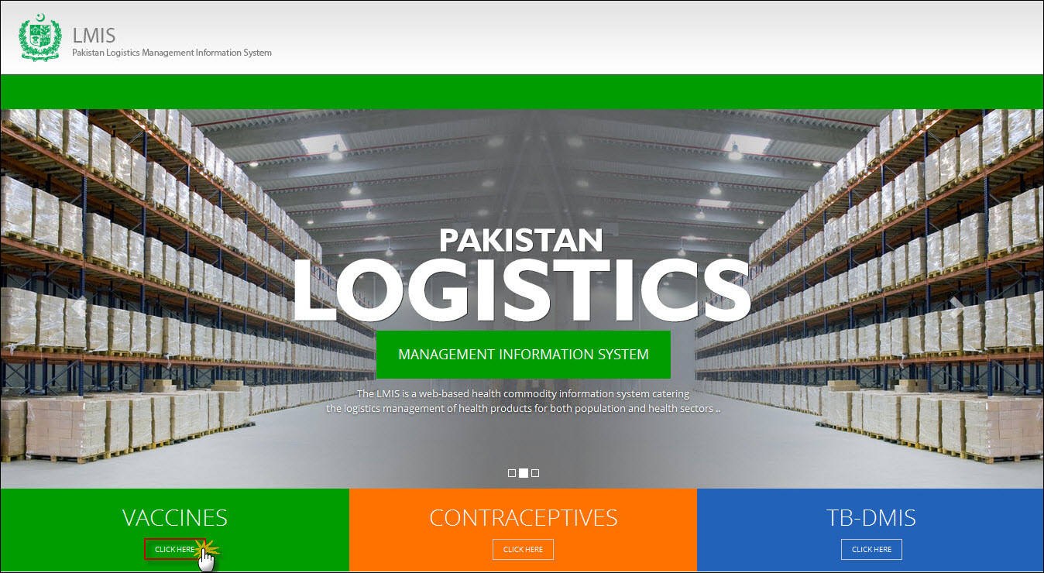**

Users can also access vaccine LMIS application directly by using <http://v.lmis.gov.pk> URL. Once the user enters the URL <http://v.lmis.gov.pk>, a user interface (homepage) will appear. The homepage displays a basic introduction to the ‘vaccine LMIS’.

|  |  |
| --- | --- |
| *C:\Users\isbah.zulfiqar\Desktop\1382615592_file_edit.png* | Before You Begin...  It is recommended to use vLMIS with Google or Mozilla Fire Fox. Older generations of browsers are also supported; however, their use can lead to issues with on-screen formatting and display. |

Once you click Vaccines, homepage for vLMIS will display.

## **Homepage Menu**

The available menu items can be found on the top of homepage screen. The components are displayed adjacently, as shown in the image below:

****

### **Contact Us Tab**

The Contact Us tab contains addresses, telephone numbers and email addresses (where available) for key personnel as a system communication list. Therefore, the user of LMIS will be able to see contact details of other stakeholders and can contact them as needed.

### **Frequently Asked Questions Tab**

The menu also contains a FAQ’s tab in order to provide guidance towards the most frequently asked and critical questions.

**Logging into Vaccine Logistics Management Information System**

vLMIS is a web-based inventory and cold chain management application that makes it simple for beginners and experienced users to report inventory and cold chain data, view performance and graphical reports as well as maps.

|  |  |
| --- | --- |
| *C:\Users\isbah.zulfiqar\Desktop\1382615592_file_edit.png* | **Before You Begin...**  Make sure you have your correct log in credentials. When you register with vLMIS, the accounts and its related details along with the login domain details will be provided to you by the vLMIS Administrator. |

To Log in to vLMIS:

1. Go to <http://v.lmis.gov.pk>
2. Click the button **Click Here** on the Vaccines tab.

vLMIS login page will be displayed.  
**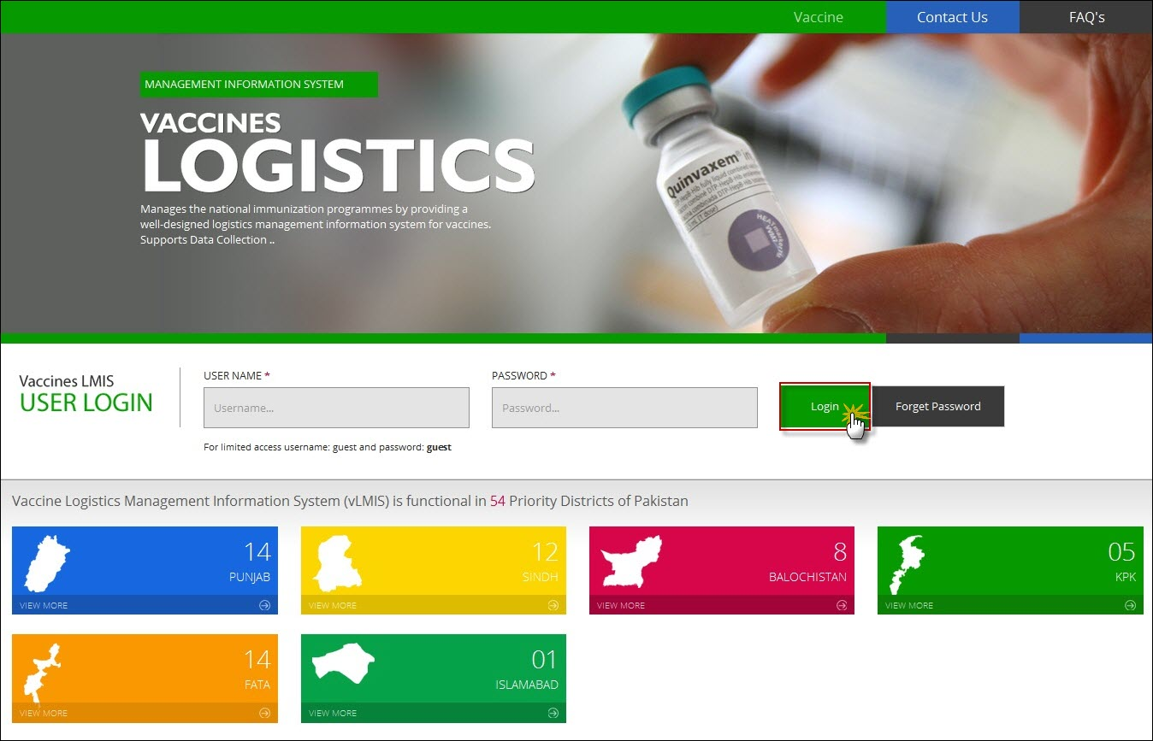**

1. Specify the **Username** and **Password** provided to you by the Administrator.

|  |  |
| --- | --- |
| *C:\Users\isbah.zulfiqar\Desktop\1382615592_file_edit.png* | To login as a guest or anonymous user, you can simply provide the following credentials:  **Username**: guest **Password**: guest |

|  |  |
| --- | --- |
|  | You can change the password provided to you by the administrator. See “*Changing Your Password*” for details.  Never give out your password to anyone for security purposes. |

1. Click **Login**.  
   The Vaccine Logistics Management Information System Dashboard Screen displays.

### **Changing Your Password**

To change your vLMIS password:

1. Login to vLMIS application.

The welcome screen displays.

1. On the right-side of the application, the user login name appears.
2. Under the login name, click Change Password as shown in the image below:

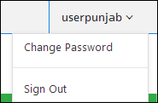

1. Specify the following:

* **Old Password**: specify your old password.
* **New Password**: specify the new password.
* **Confirm New Password**: retype your password.

|  |  |
| --- | --- |
| *C:\Users\isbah.zulfiqar\Desktop\1382615592_file_edit.png* | Password Requirements  Your password must have a combination of a capital alphabet and one Numeric. |

|  |  |
| --- | --- |
|  | Never give out your password to anyone for security purposes. |

1. Click **Change Password**.  
   Your password will be changed successfully.

### **Forgot Password**

In case you have forgotten your password:

1. Open the vLMIS login page by entering the URL: <http://v.lmis.gov.pk>.
2. In the Login section, click **Forgot Password** as shown in the image below:  
     
   **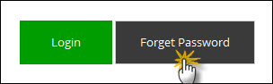**

You will be redirected to the Forgot Password Page.

1. In the Email entry box, enter your email address as validated in your account information by the Administrator.   
   An email will be sent on your email address for resetting your password.
2. Click the Reset Password link in the email to go to reset password page.
3. Specify the following:
   * **New Password**: specify the new password.
   * **Confirm New Password**: retype your password.

|  |  |
| --- | --- |
| *C:\Users\isbah.zulfiqar\Desktop\1382615592_file_edit.png* | Password Requirements  Your password must have a combination of a capital alphabet and one Numeric. |

|  |  |
| --- | --- |
|  | Never give out your password to anyone for security purposes. |

1. Click **Change Password**.  
   Your password will be changed successfully.

### **Logging Out**

When signed in, click **Sign out** on the right-side of the application, as shown in the image below:  
  


|  |  |
| --- | --- |
| CCEM Reports and Graphs | **4** |
| in Vaccine Logistics Management Information System | |

This section explains the step-by-step instructions on the CCEM reports and graphs features that can be used by the Vaccine Logistics Management Information system’s users.

# Overview

The Vaccine Logistics Management Information System enables you to login as an authenticated user to view many reports and graphs. These users can view analytical reports and graphical data for any period using selection filters.

# CCEM Reports

The CCEM Reports section provides a list of frequently used reports that are generated quickly at the central level to help national cold chain managers to analyze the cold chain equipment. All CCEM reports can be found in the main menu which can be generated for a regional subset or a select health facility type.

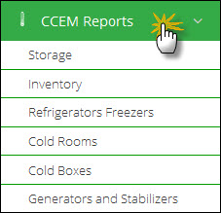

## **Storage**

The storage menu can be viewed by selecting the “Storage” tab in the sub-menu. The drop down menu will be displayed as follows:

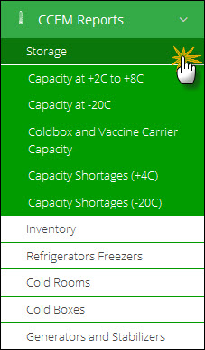

#### **Capacity at +2c to +8c**

User can select following filters according to their requirements. Available filters are as follows:

1. Facility Type
2. Office
3. Province
4. District

Click **Search.**

**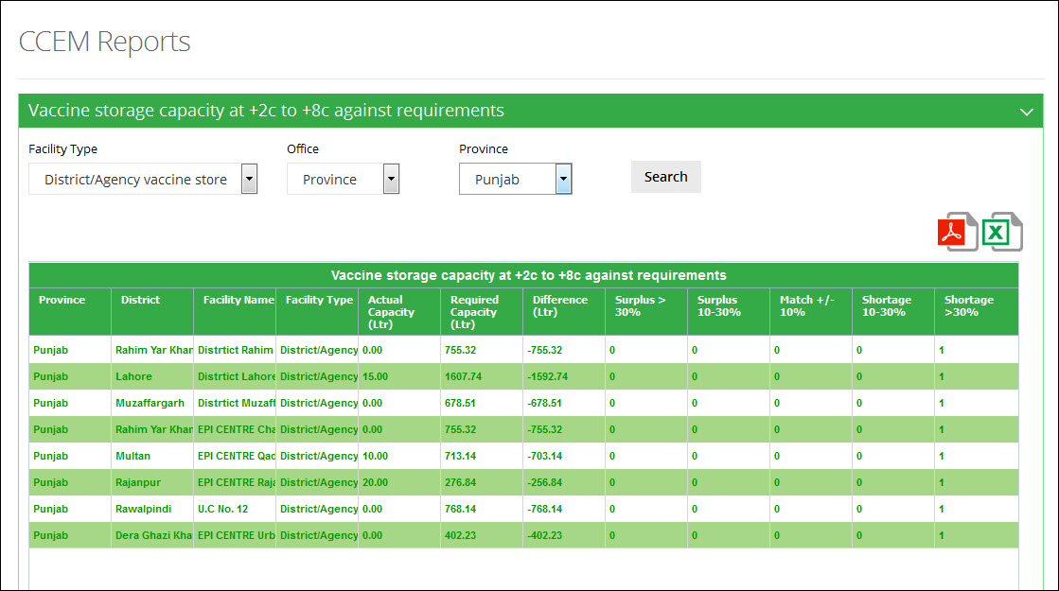**

**Use Filter options to filter data in the table below**

#### **Capacity at -20c**

User can select following filters according to their requirements. Available filters are as follows:

1. Facility Type
2. Office
3. Province
4. District

Click **Search.**

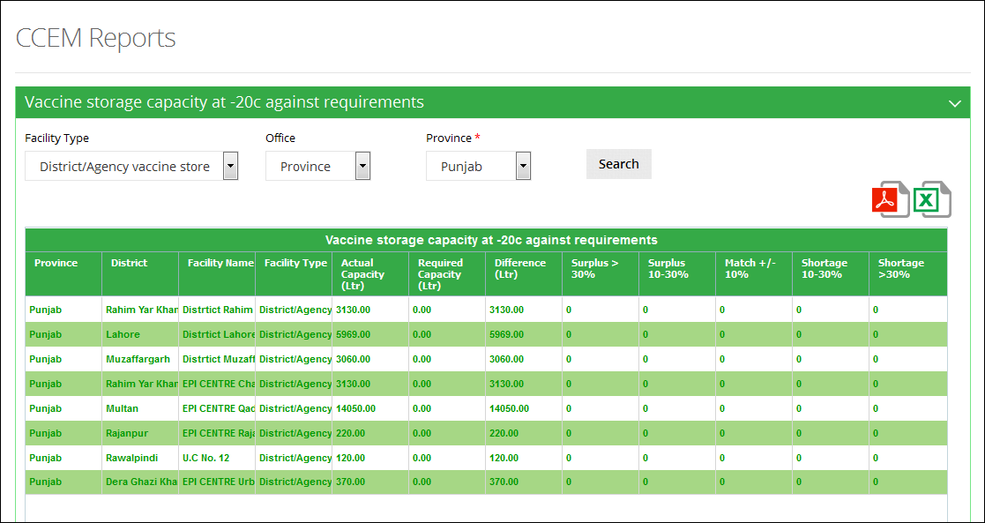

**Use Filter options to filter data in the table below**

#### **Cold-box and Vaccine Carrier Capacity**

User can select following filters according to their requirements. Available filters are as follows:

1. Facility Type
2. Office
3. Province
4. District

Click **Search.**

**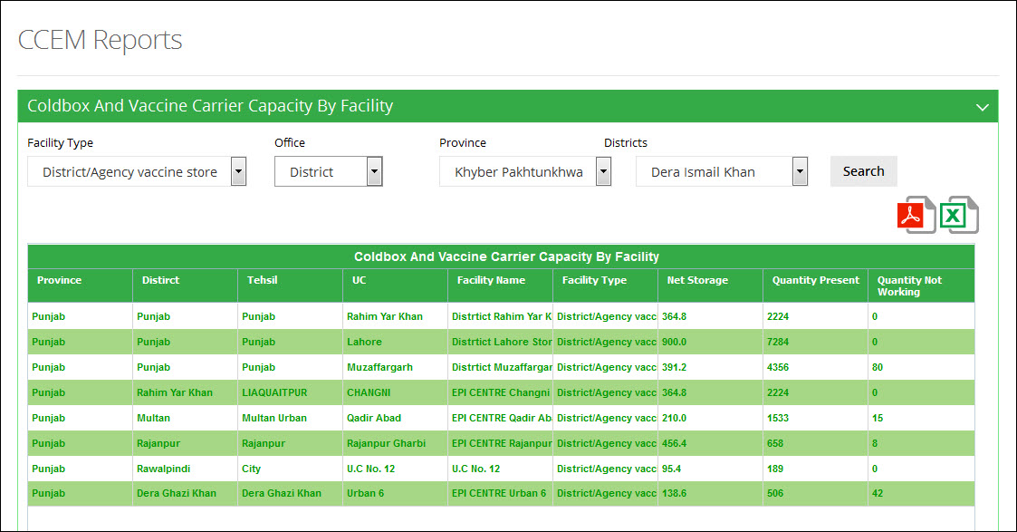**

**Use Filter options to filter data in the table below**

#### **Capacity Shortages (+4C)**

User can select following filters according to their requirements. Available filters are as follows:

1. Facility Type
2. Office
3. Province
4. District

Click **Search.**

**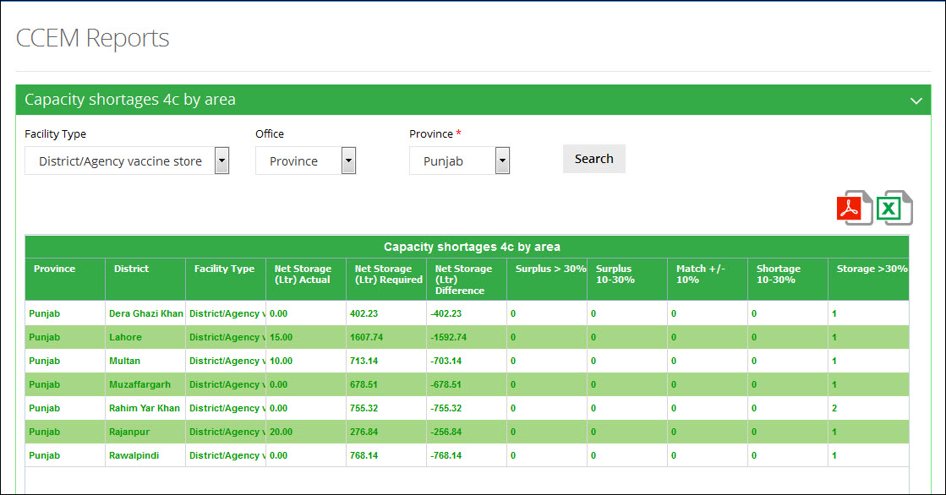**

**Use Filter options to filter data in the table below**

#### **Capacity Shortages (-20C)**

User can select following filters according to their requirements. Available filters are as follows:

1. Facility Type
2. Office
3. Province
4. District

Click **Search.**

**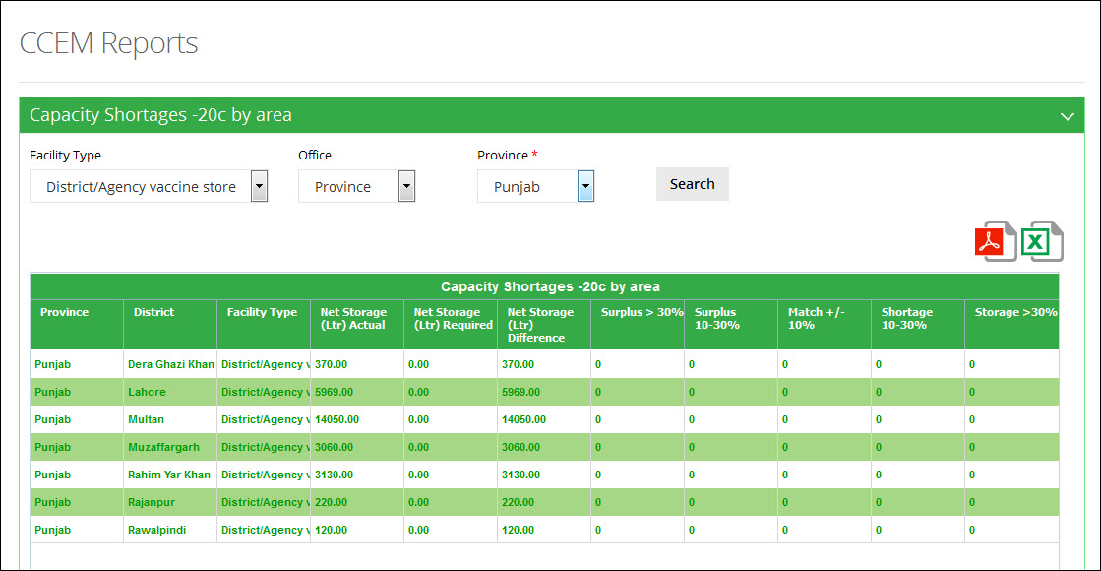**

**Use Filter options to filter data in the table below**

## **Inventory**

The inventory menu can be viewed by selecting the “Inventory” tab in the sub-menu. The drop down menu will be displayed as follows:

**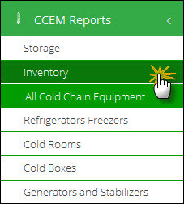**

#### **All Cold Chain Equipment**

User can select following filters according to their requirements. Available filters are as follows:

1. Facility Type
2. Office
3. Province
4. District

Click **Search.**

**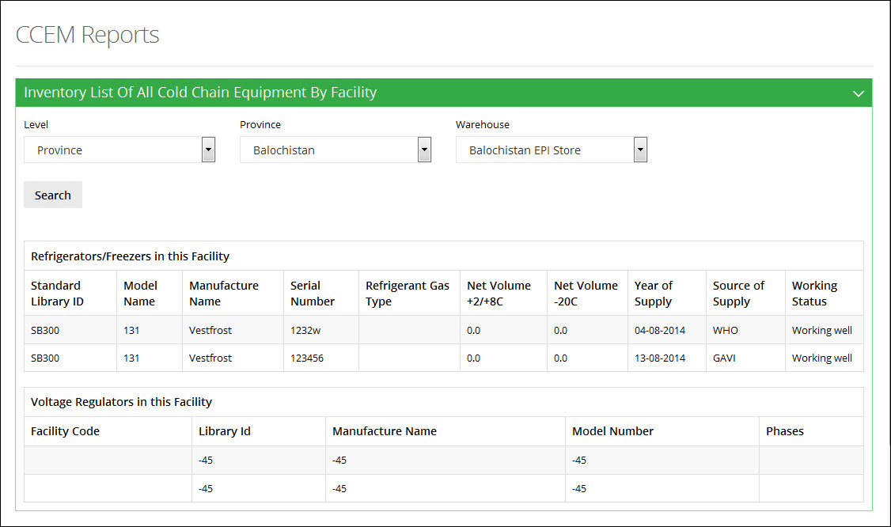**

**Use Filter options to filter data in the table below**

## **Refrigerators Freezers**

The refrigerators freezers menu can be viewed by selecting the “Refrigerators Freezers” tab in the sub-menu. The drop down menu will be displayed as follows:

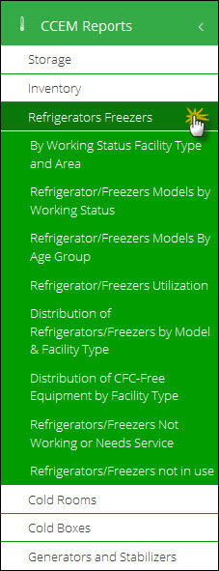

#### **By Working Status Facility Type and Area**

User can select following filters according to their requirements. Available filters are as follows:

1. Facility Type
2. Office
3. Province
4. District

Click **Search.**

A report for refrigerator/freezers according to the working status, facility type and area will be displayed.

**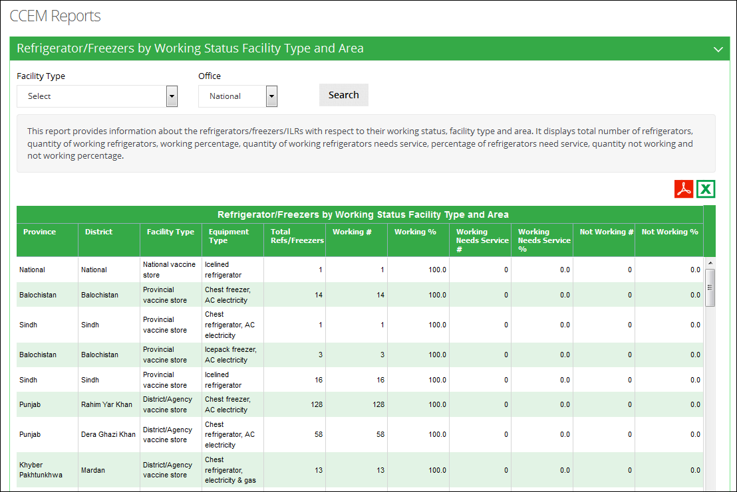**

**Use Filter options to filter data in the table below**

#### **Refrigerators/Freezers Models by Working Status**

User can select following filters according to their requirements. Available filters are as follows:

1. Facility Type
2. Office
3. Province
4. District

Click **Search.**

A report for the refrigerator/freezers models available according to the working status is displayed.

**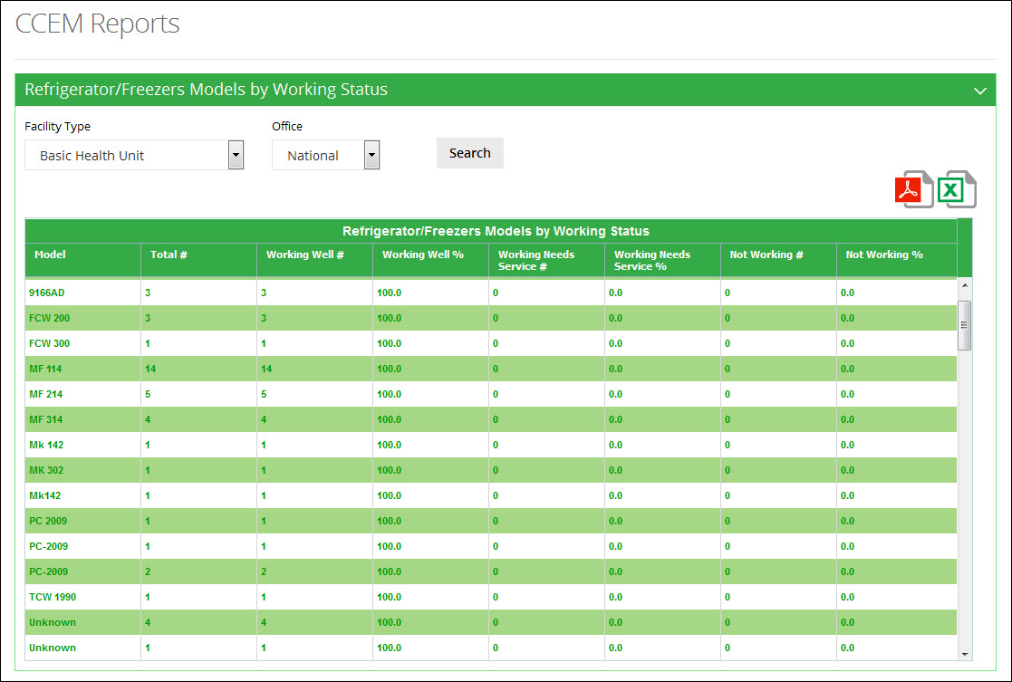**

**Use Filter options to filter data in the table below**

#### **Refrigerators/Freezers Models by Age Group**

User can select following filters according to their requirements. Available filters are as follows:

1. Facility Type
2. Office
3. Province
4. District

Click **Search.**

A report for refrigerator/freezers models according to the age group will be displayed.

**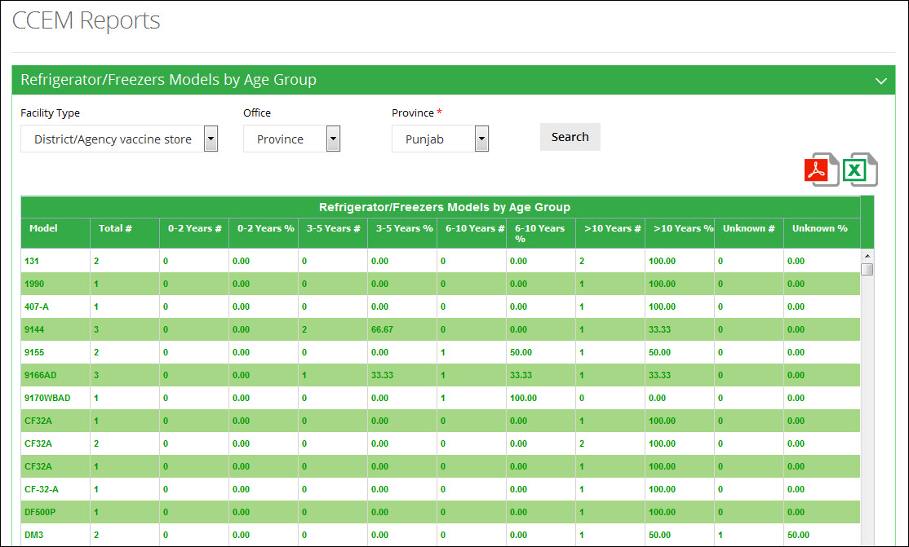**

**Use Filter options to filter data in the table below**

#### **Refrigerators/Freezers Utilization**

User can select following filters according to their requirements. Available filters are as follows:

1. Facility Type
2. Office
3. Province
4. District

Click **Search.**

A report about the utilization of refrigerator/freezers in the selected province / district will be displayed.

**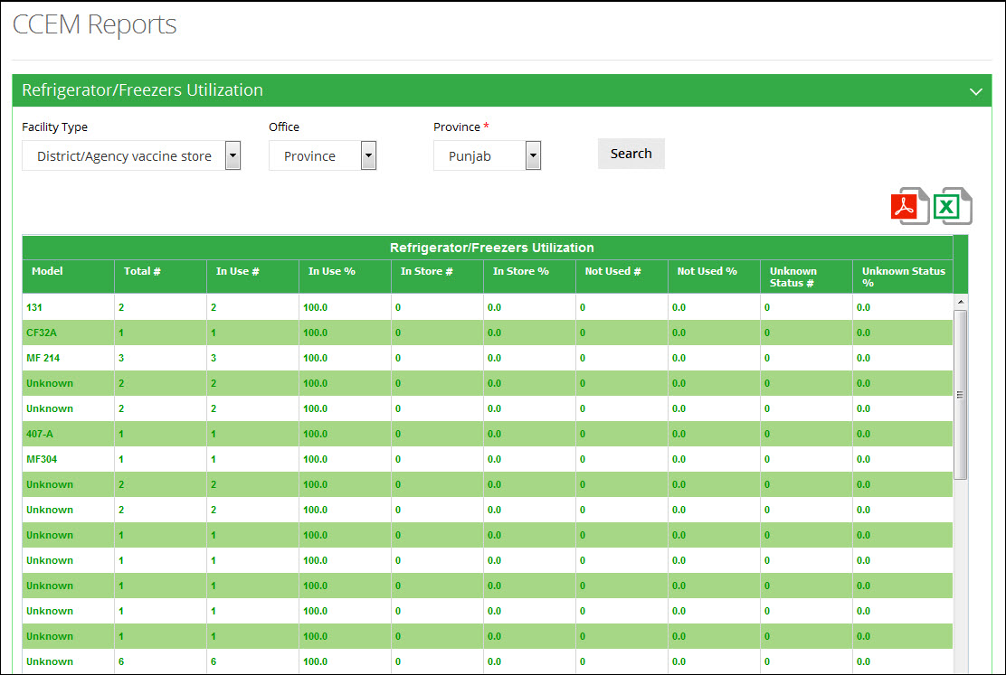**

**Use Filter options to filter data in the table below**

#### **Distribution of Refrigerators/Freezers by Model & Facility Type**

User can select following filters according to their requirements. Available filters are as follows:

1. Office
2. Province

Click **Search.**

A report for the distribution of refrigerator/freezers according to the model and facility type will be displayed.

**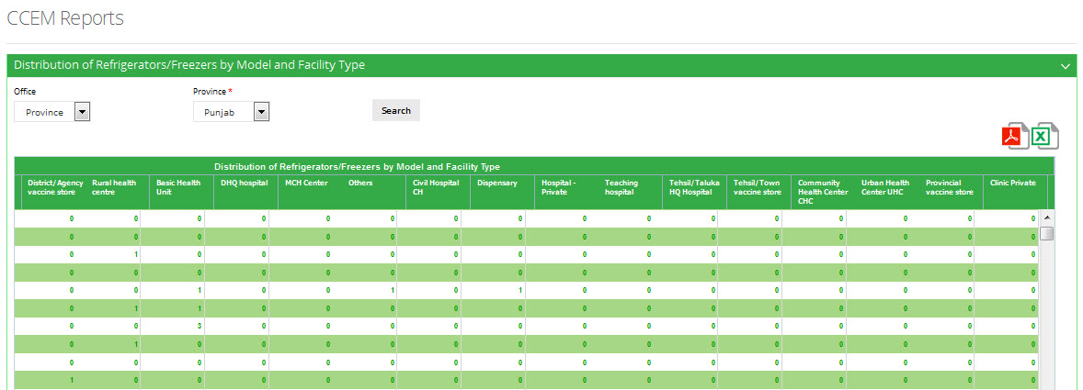**

#### **Distribution of CFC-Free Equipment by Facility Type**

User can select following filters according to their requirements. Available filters are as follows:

1. Facility Type
2. Office
3. Province
4. District

Click **Search.**

**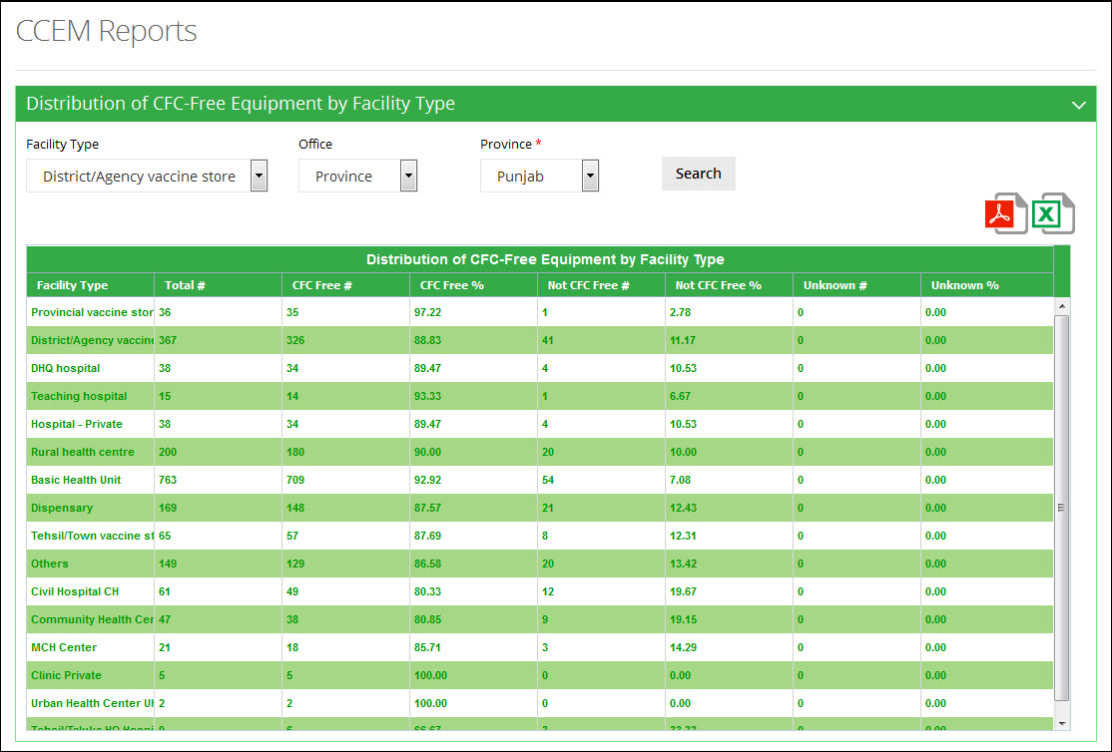**

#### **Refrigerators/Freezers Not Working or Needs Service**

User can select following filters according to their requirements. Available filters are as follows:

1. Facility Type
2. Office
3. Province
4. District

Click **Search.**

**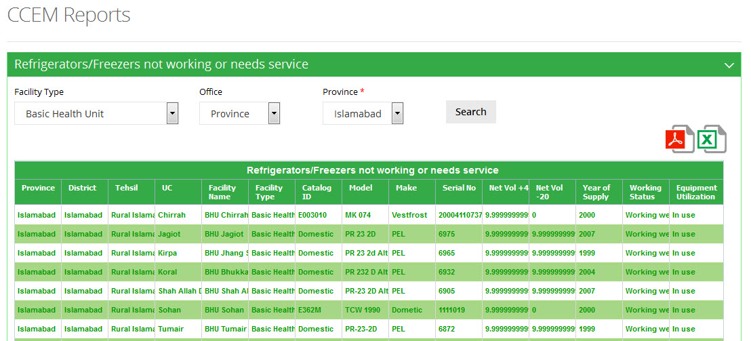**

#### **Refrigerators/Freezers not in use**

User can select following filters according to their requirements. Available filters are as follows:

1. Office
2. Province

Click **Search.**

**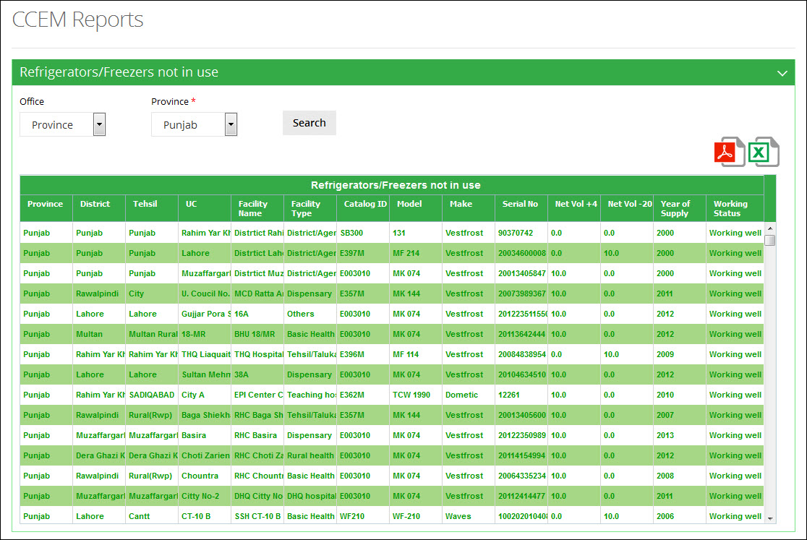**

## **Cold Rooms**

This menu can be viewed by selecting the “Cold Rooms” tab in the sub-menu. The drop down menu will be displayed as follows:

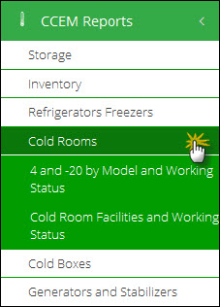

#### **4 and -20 by Model and Working Status**

User can select following filters according to their requirements. Available filters are as follows:

1. Facility Type
2. Office
3. Province
4. District

Click **Search.**

**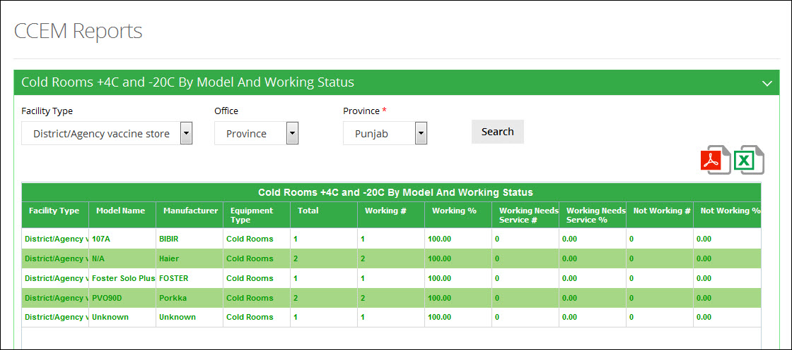**

#### **Cold Room Facilities and Working Status**

User can select following filters according to their requirements. Available filters are as follows:

1. Facility Type
2. Office
3. Province
4. District

Click **Search.**

**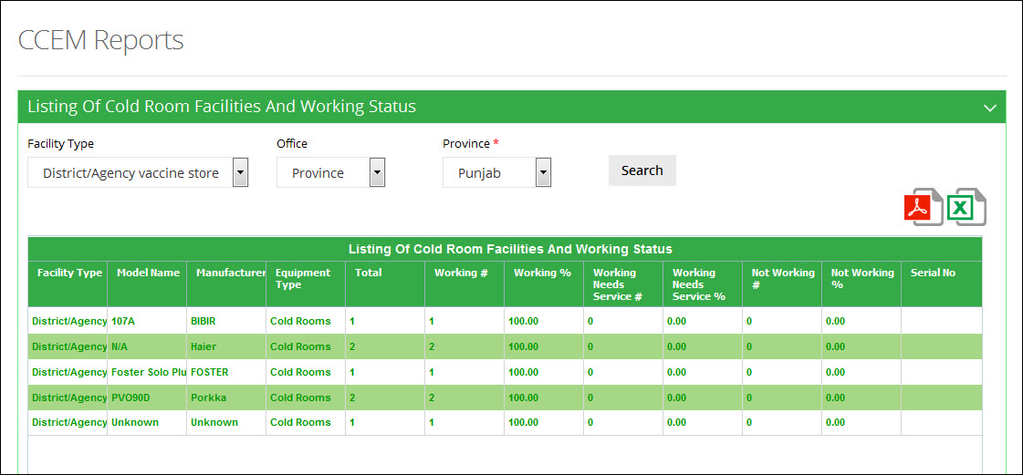**

## **Cold Boxes**

This menu can be viewed by selecting the “Cold Boxes” tab in the sub-menu. The drop down menu will be displayed as follows:

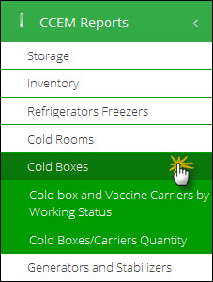

#### **Cold box and Vaccine Carriers by Working Status**

User can select following filters according to their requirements. Available filters are as follows:

1. Facility Type
2. Office
3. Province
4. District

Click **Search.**

**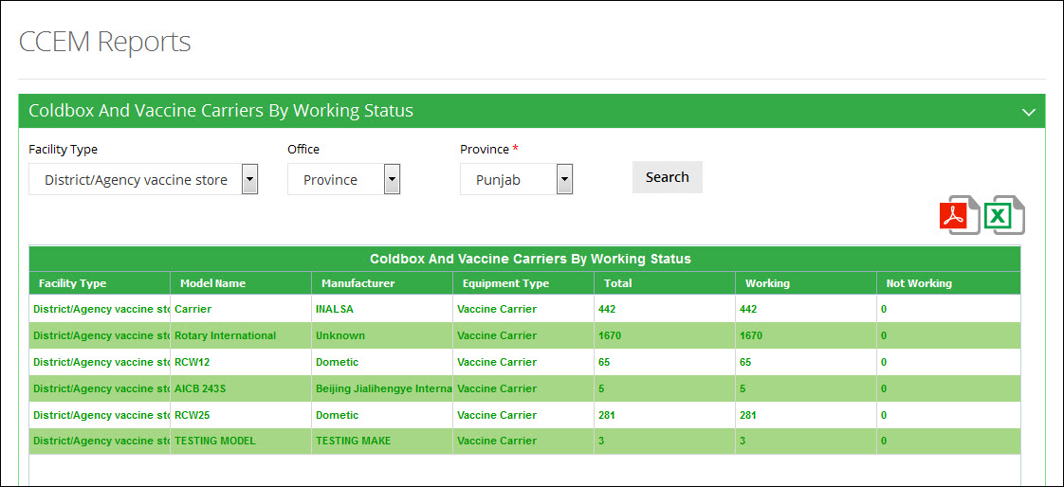**

#### **Cold Boxes/Carriers Quantity**

User can select following filters according to their requirements. Available filters are as follows:

1. Facility Type
2. Office
3. Province
4. District

Click **Search.**

**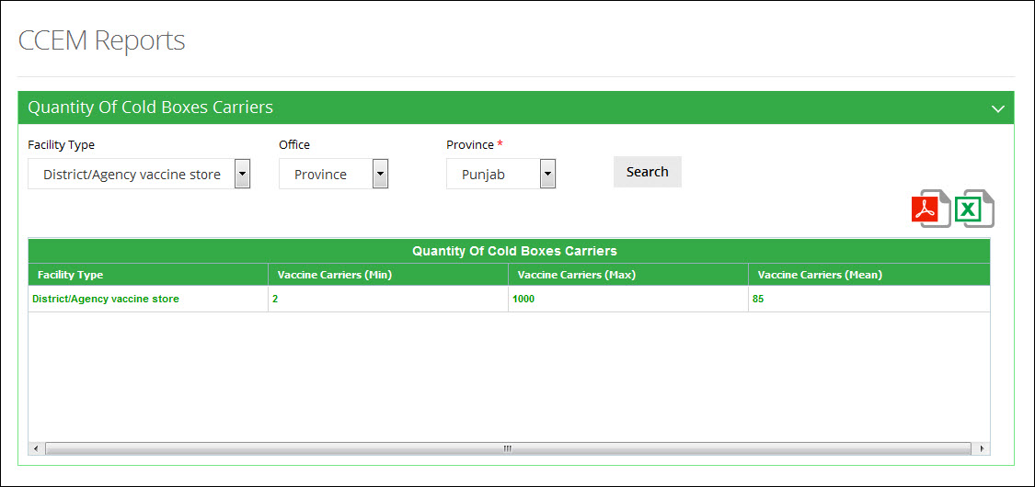**

## **Generators and Stabilizers**

This menu can be viewed by selecting the “Generators and Stabilizers” tab in the sub-menu. The drop down menu will be displayed as follows:

**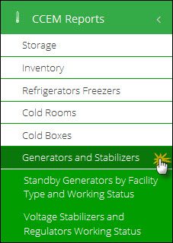**

#### **Standby Generators by Facility Type and Working Status**

User can select following filters according to their requirements. Available filters are as follows:

1. Facility Type
2. Office
3. Province
4. District

Click **Search.**

**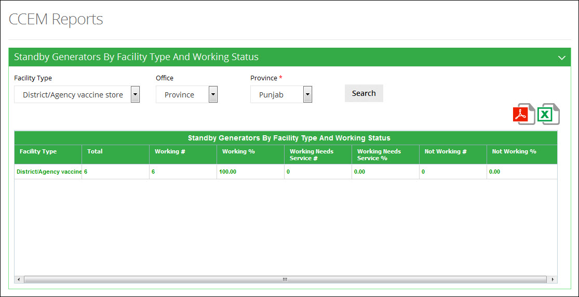**

#### **Voltage Stabilizers and Regulators Working Status**

User can select following filters according to their requirements. Available filters are as follows:

1. Facility Type
2. Office
3. Province
4. District

Click **Search.**

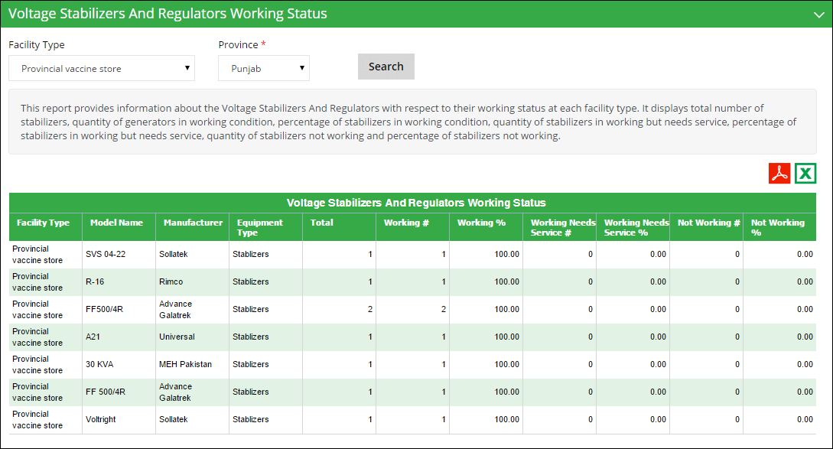

**Use Filter options to filter data in the table below**

# CCEM Graphs

Clicking on **CCEM Graph** menu displays the list of Graphs related to cold-chain equipment management, as shown in the image below:

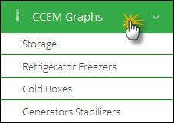

There are the following different types of graph reports:

* **Storage**: enables you to compare different indicators to determine capacity.
* **Refrigerator Freezers**: enables you to the status of refrigerators and freezers.
* **Cold Boxes:** enables you to determine the status of cold-boxes.
* **Generators Stabilizers:** enables you to determine the status of generators and stabilizers.

## **Storage**

Clicking on **Storage** sub-menu displays the list of Graphs related to storage management, as shown in the image below:

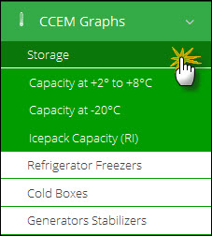

#### **Capacity at +2c to +8c**

User can select following filters according to their requirements. Available filters are as follows:

1. Facility Type
2. Office
3. Province
4. District

Click **Search.**

The desired graph is displayed as follows:

**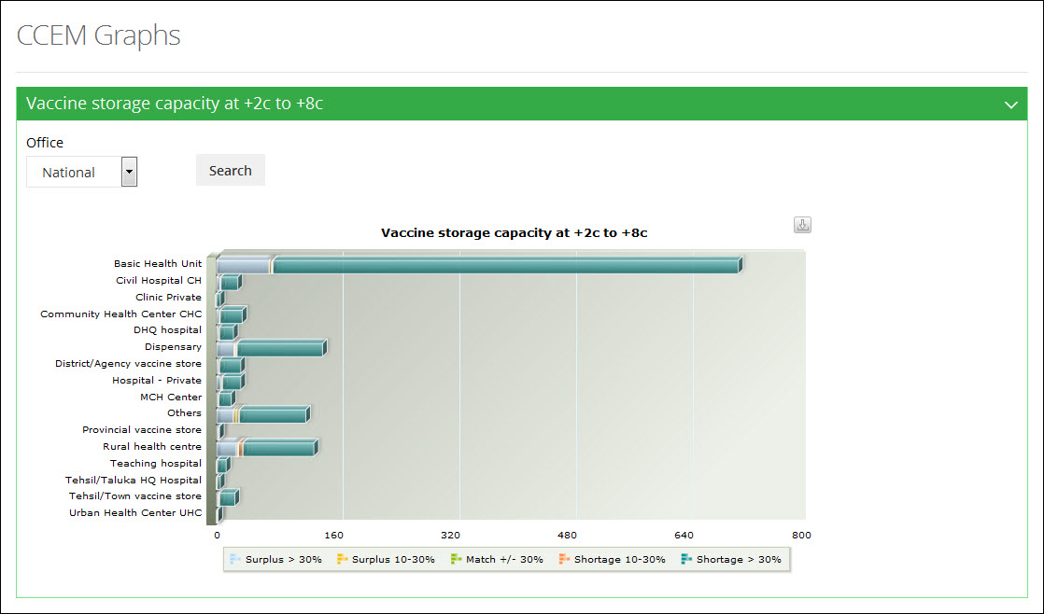**

#### **Capacity at -20C**

User can select following filters according to their requirements. Available filters are as follows:

1. Office
2. Province
3. District

Click **Search.**

The desired graph is displayed as follows:

**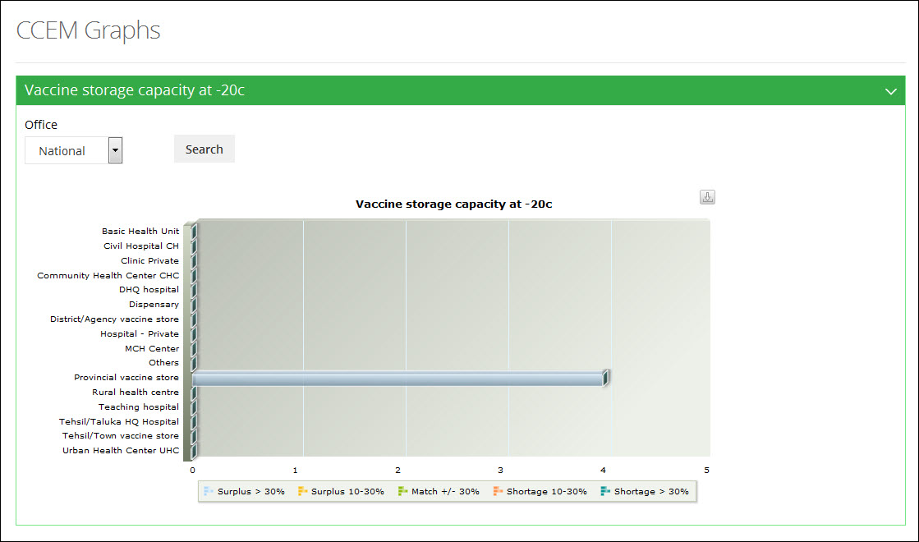**

#### **Icepack Capacity (RI)**

User can select following filters according to their requirements. Available filters are as follows:

1. Office
2. Province
3. District

Click **Search.**

The desired graph is displayed as follows:

**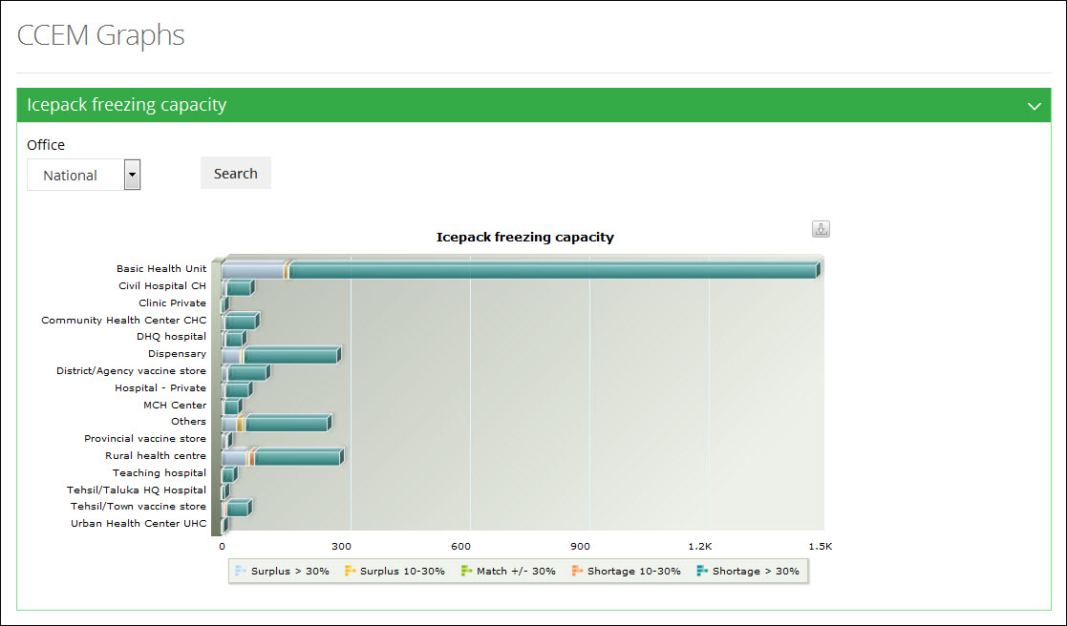**

## **Refrigerator Freezers**

Clicking on **Refrigerator Freezers** sub-menu displays the list of Graphs related to cold-chain equipment management, as shown in the image below:

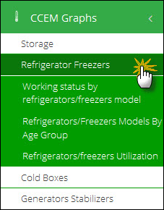

#### **Working Status by Refrigerators Model**

User can select following filters according to their requirements. Available filters are as follows:

1. Facility Type
2. Office
3. Province
4. District

Click **Search.**

The desired graph is displayed as follows:

**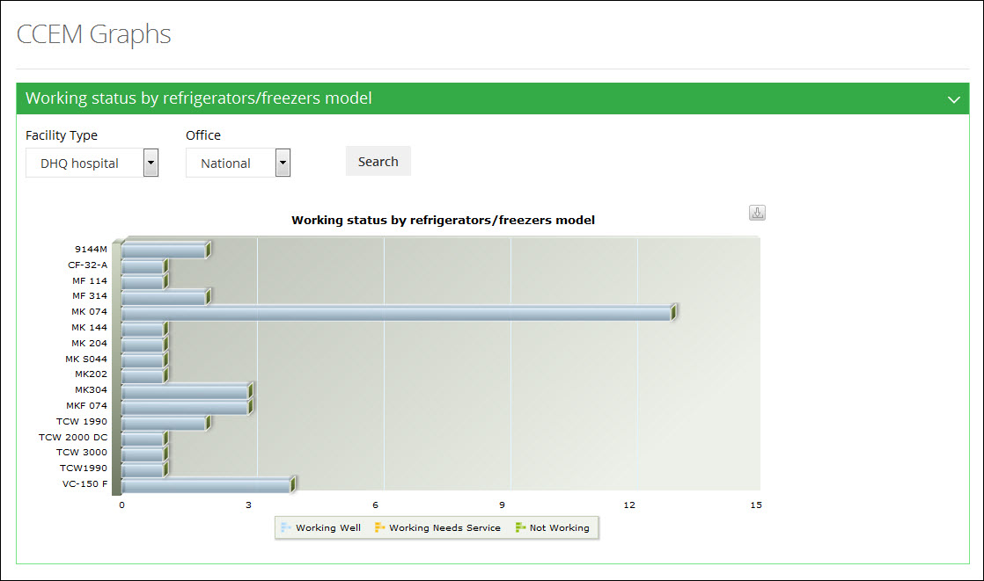**

#### **Refrigerators / Freezers Model By Age Group**

User can select following filters according to their requirements. Available filters are as follows:

1. Office
2. Province
3. District

Click **Search.**

The desired graph is displayed as follows:

**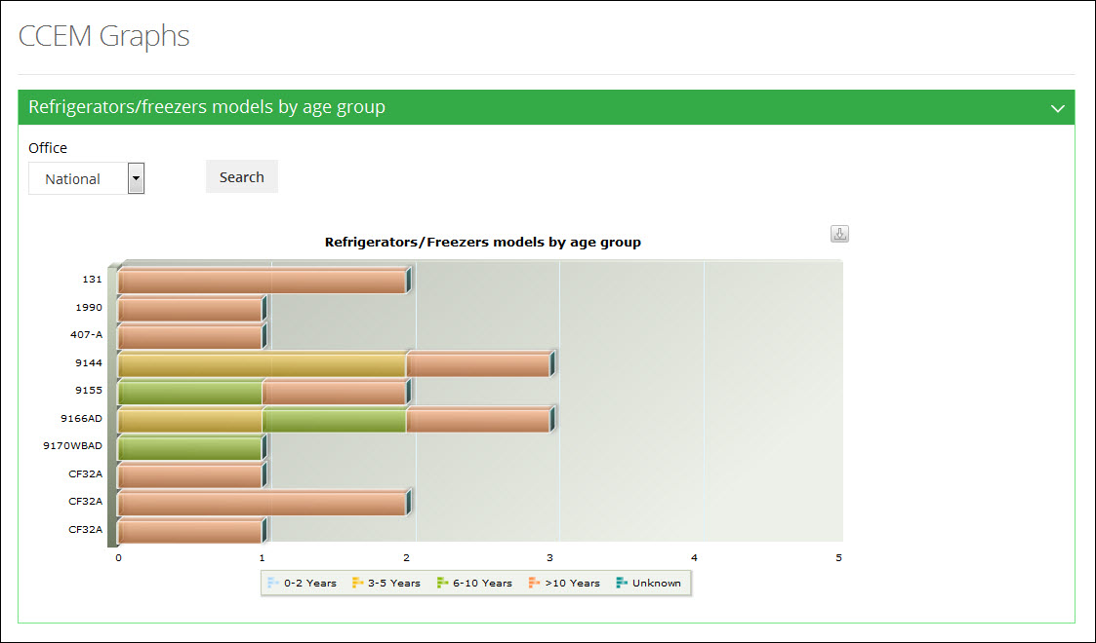**

#### **Refrigerators / Freezers Utilization**

User can select following filters according to their requirements. Available filters are as follows:

1. Facility Type
2. Office
3. Province
4. District

Click **Search.**

The desired graph is displayed as follows:

**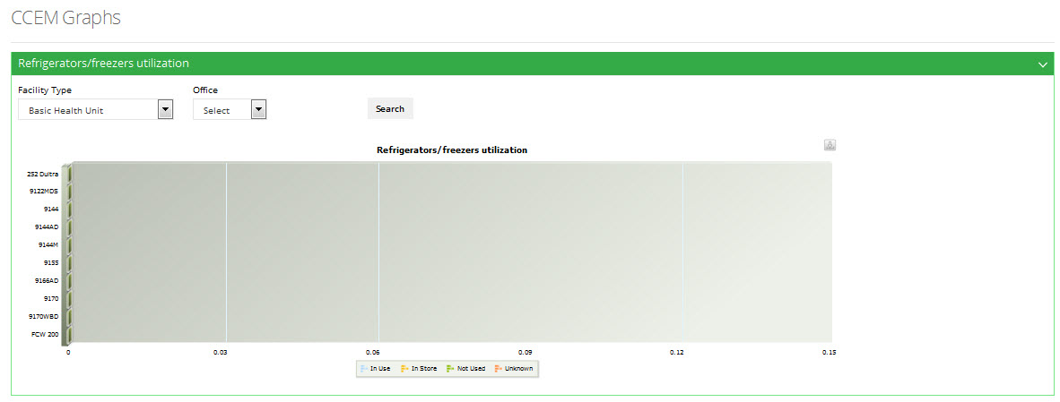**

## **Cold Boxes**

Clicking on **Cold Boxes** sub-menu displays the list of Graphs related to cold-chain equipment management, as shown in the image below:

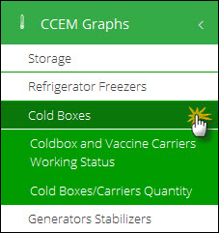

#### **Cold-box and Vaccine Carriers Working Status**

User can select following filters according to their requirements. Available filters are as follows:

1. Office
2. Province
3. District

Click **Search.**

The desired graph is displayed as follows:

**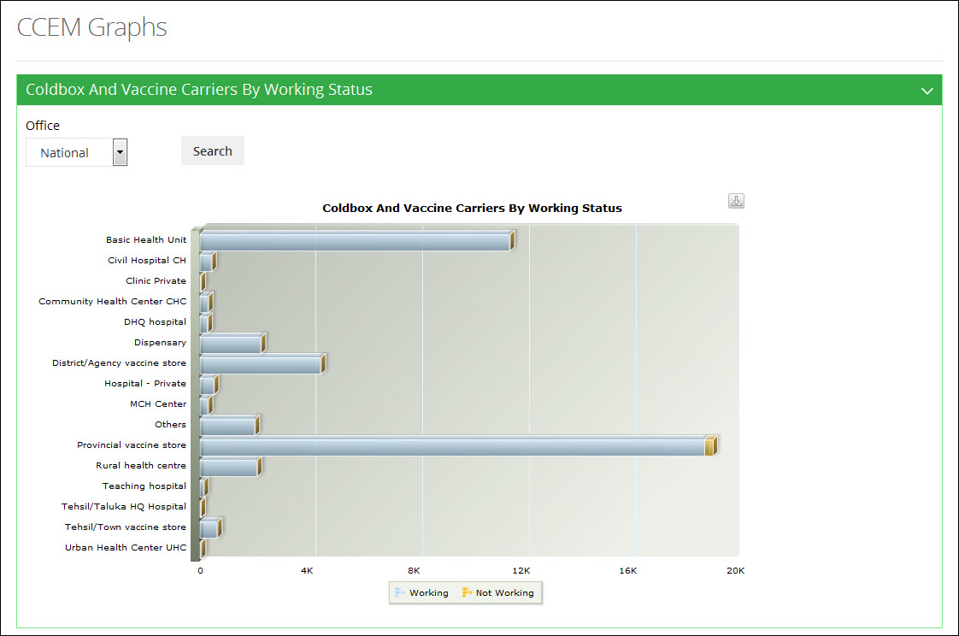**

#### **Cold-boxes / Carrier Quantity**

User can select following filters according to their requirements. Available filters are as follows:

1. Office
2. Province
3. District

Click **Search.**

The desired graph is displayed as follows:

**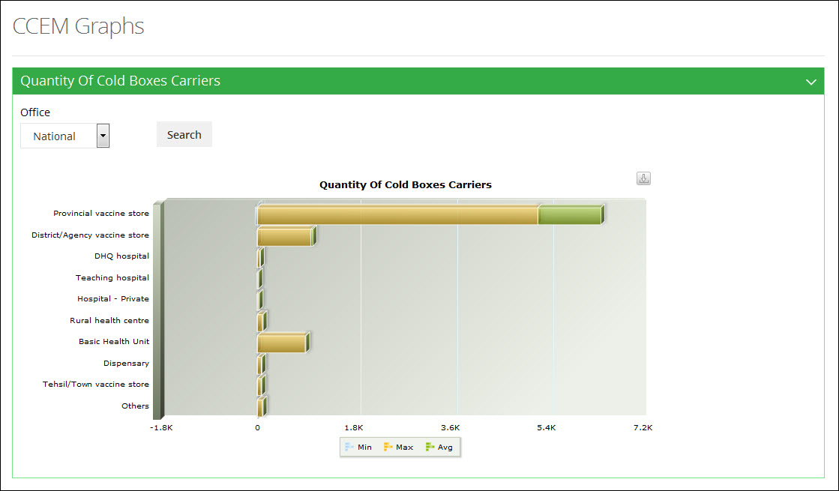**

## **Generators Stabilizers**

Clicking on **Generators Stabilizers** sub-menu displays the list of Graphs related to cold-chain equipment management, as shown in the image below:

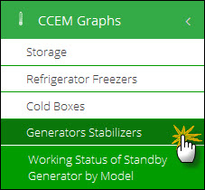

#### **Working Status of Standby Generator by Model**

User can select following filters according to their requirements. Available filters are as follows:

1. Office
2. Province
3. District

Click **Search.**

The desired graph is displayed as follows:

**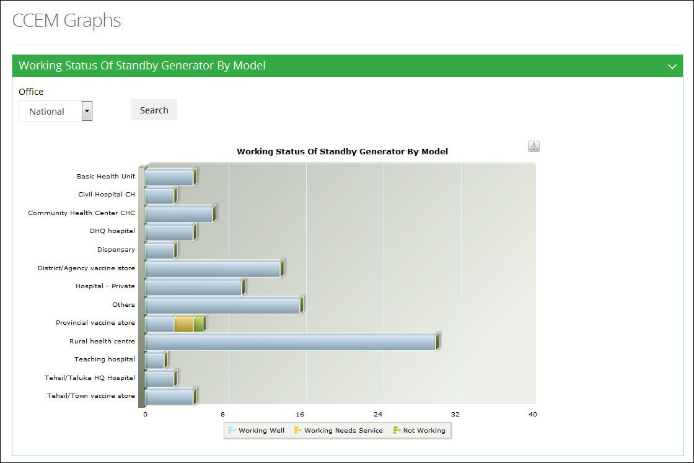**

|  |  |
| --- | --- |
| Cold-chain | **5** |
| in Vaccine Logistics Management Information System | |

This section explains the overview of the cold-chain logistics and its importance in the Logistics Management Information System.

# Cold Chain Logistics

The Expanded Program on Immunization (EPI) was launched in 1978 in Pakistan to reduce death, disease, and disability due to vaccine preventable diseases (VPDs), and to contribute to the strengthening of national health systems. EPI services are provided through the public health delivery network through fixed centers and outreach services.

Improving routine immunization is one of the key indicators of EPI for ensuring a reduction in childhood mortality in Pakistan. However, improving routine immunization remains a major challenge in Pakistan. Many children are being needlessly affected by measles and other vaccine preventable diseases despite the availability of safe and effective vaccines, one of the factors being that there is inadequate capacity to **manage vaccine cold chain effectively**. A huge part of vaccines is **wasted or expired** due to ineffective cold chain during the supply chain process, therefore in June 2013, the USAID | DELIVER PROJECT, in collaboration with federal and provincial Expanded Program on Immunization (EPI) stakeholders, UNINCEF and WHO collaborated to review the performance of vaccine and cold chain logistics management and supply chain systems and decided that it was essential to integrate vaccine logistics into an online system, possibly extending the existing Pakistan Web-based LMIS to include a Vaccine and a Cold Chain Logistics module.

The requirements of the vaccine and cold chain logistics management system were discussed and all stakeholders worked to define a common vision for the enhancement of the Web-based LMIS for vaccines. Based on their review, stakeholders endorsed the Web-based LMIS in Pakistan (supported by the USAID | DELIVER PROJECT and John Snow, Inc.) as a model for a new vLMIS that would be accessible through a web portal, provide transparency to all stakeholders based on user rights, is easy to use, enables reporting via mobile devices (SMS), and integrates both routine and campaign vaccine logistics data. Standardized reporting forms were also recommended, along with more timely review and tracking reporting rates and timeliness. Data triangulation is recommended to validate data and improve visibility in wastage rates. One important recommendation was that the resupply quantities for routine EPI should be calculated based on average monthly consumption and stock balances, and that wastage rates should be calculated automatically if feasible. Finally, there was a consensus that timely budget release, appropriate training, improved monitoring and supervision, and adequate IT support were vital to improving vaccine logistics data collection, management, and use.

This report was presented to the Ministry of National Health Services, Regulation and Coordination, includes the findings of the assessment, as well as the recommended high-level functional and system requirements for extending the Web-based LMIS to include a vaccine logistics management information system (vLMIS) module.

## **Why is Cold Chain Logistics important?**

Cold chain logistics refer to the system of people, policies, procedures, vehicles, fuel, equipment, and technologies that work together to make sure that vaccines given to people are safe and effective. Because most vaccines have specific temperature requirements, the cold chain logistics management system would prevent both excessive heat and cold from damaging the vaccines from the time of manufacturing until they are used. The refrigerated movement of temperature sensitive vaccines, pharmaceuticals and medical supplies is vital for the shelf life of vaccine drugs relies heavily on controlled and uncompromised transfer of shipments.

An effective logistics system is incomplete without a well-maintained cold chain for safe and effective immunization service delivery. An improperly functioning cold chain can lead to wasted vaccines, missed opportunities to immunize due to lack of vaccines, and children receiving vaccines that do not protect them as intended or that actually make them sick.

**Insufficient, outdated and broken cold chain equipment are often cited as major problems** affecting routine immunization efforts during country immunization program reviews and supervisory visits. Additional problems are lack of technically-trained staff and inadequate financing for procuring new equipment and transporting technicians and/or broken equipment.

Outdated equipment is still in use and often needed as back-up due to delays in providing new equipment, insufficient stock capacity (both permanent and temporary, if the equipment is being used for immunization campaigns), or occasional problems with new equipment (e.g. lack of spare parts or appropriate tools).

There is often a lack of field-based procurement and repair plans, which means that cold chain and logistics inventories are not sufficiently linked with new equipment projections. This makes it difficult for countries to prioritize districts and provinces with the greatest need for new equipment.

## **Environmental factors**

Poor or unreliable energy sources, a common problem in developing countries, weaken the effectiveness of equipment and shorten its lifespan. Also, equipment in remote areas is difficult to reach with timely repairs and routine maintenance, which are necessary to avoid more costly repairs or replacement.

The Expanded Program on Immunization emphasizes monitoring vaccine stocks and temperatures at all levels of storage, distribution and administration in order to avoid or reduce wastage.

Monitoring tools include vaccine vial monitors and freeze watch indicators. In addition, electronic temperature data loggers have been introduced at the regional level to 1) monitor the transportation of freeze-sensitive vaccines and 2) randomly study the storage temperatures of some refrigerators over a defined period of time.

There is inadequate capacity to manage cold chain effectively.

## **Cold Chain Module in vLMIS**

The National Vaccine Management Committee (NVMC) requested USAID to support enhancing the existing web-LMIS to include a module for managing vaccine and cold chain data. This new module will be referred to as the vaccine logistics management information system (vLMIS).

The reason for developing an online cold chain module is the lack of cold chain data. Despite the heavy investment by development partners and the GOP, no credible information and inventory systems exist at the municipal Union Council (UC), district, provincial, nor even federal levels.

Logistics management information system (LMIS) data for vaccines below the national level is mainly paper-based and therefore largely inaccessible to vertical program managers. The data currently originates from forms filled at the health facilities and is only partially turned into accessible digital information in Excel spreadsheets at either district or provincial levels.

The limited information for vertical program managers and district administrations is manually aggregated through the districts and/or provinces. It is sometimes estimated and often incomplete. This hinders the ability of managers to procure the right quantities and effectively oversee supply chain performance.

Currently, UNICEF is supporting a national cold chain inventory that will collect data on existing cold chain equipment (age, type, capacity, operability) as well as facility profile data. This will help identify gaps in the cold chain storage capacity and functionality that need to be addressed.

However, there are significant challenges in the collection, use and management of cold chain since Wastage (due to open vial) data are under-reported and poorly tracked.

Key data requirements were also agreed, emphasizing simplicity and minimal data for the initial version of the vLMIS (with suggestions for future additions) and mandating use of stock balance, consumption and issues data, losses and adjustments as the essential data items to collect. New routine reporting forms will be developed to collect this data from service delivery points, along with vaccine logistics standard operating procedures (SOPs) for each level of the supply chain. Data will be entered at either the Union Council level (if Internet access is available) or at the district level, and the vLMIS will also include a warehouse management system module for inventory management at the district, provincial, and national EPI stores. The vLMIS will also receive periodic SMS reports from vaccinators (more frequent than monthly, but period is yet to be determined) that include consumption, wastage, and balance. These data will be used to validate the monthly reports from service delivery points. The system will enable continued use of the existing SOPs and forms for polio campaigns, but the inventory data from stores will be integrated and vaccinators will report via SMS daily during the campaigns.

The design, construction and testing of the vLMIS is expected to be completed by December 2013, and will be deployed for a pilot phase to the polio endemic districts first before national rollout. A vLMIS Project Charter will be developed and approved by the NVMC to ensure adequate stakeholder engagement and commitment to the vLMIS, to document project parameters and deliverables, and to establish project management and governance structures.

## **Cold Chain Storage**

Currently, there is a well-established network of cold stores at each level down to the district (except in Azad Jammu and Kashmir, and Gilgit-Baltistan). At the national level, cold and bulk storage is sufficient for all commodities, but not at provincial, district, or sub-district and UC level. Punjab has upgraded cold chain equipment provided by USAID in 2013, and Khyber Pakhtunkhwa has started upgrading its cold store. Good storage conditions are maintained at federal level, while conditions vary from province to province and district to district. Cold chain equipment is maintained at all levels (with a few exceptions at district & UC levels) and cold chain failures are dealt with timely and appropriately at the provincial level, with some delays at district & sub district level. There are some personnel trained in and capable of providing cold chain maintenance.

Cold & bulk storage space is inadequate at provincial (except in Punjab), district, and SDP levels, and the cold rooms at both national and provincial levels are not purpose built for maximum operational and energy efficiency, as they now rely on multiple smaller cold rooms that vent heat into the bulk storage area. Interruption of electricity supply is common place and there is a lack of power back up at all levels. The quality of cold chain equipment at district & sub-district levels is not optimal, and many lack voltage stabilizers. There is a shortage of trained and qualified cold chain technicians to service all EPI stores and equipment in a timely manner.

## **Recommendations**

The cold chain system needs to be upgraded at all levels, with particular attention to provincial level and below. Design standards that emphasize operational and energy efficiency should be developed for national, provincial, and district cold stores so that investments in upgrades contribute to optimize storage procedures, reduced energy consumption and cost containment. Upgrades must also include back up power systems; if generators are included, adequate long-term budget support is required for fuel. At lower levels, solar ice liners refrigerators (ILRs) should be based on the newest sustainable technology (solar chill) for areas with high incidence of power interruptions. Any new equipment investment must also include training for technical staff on maintaining and repairing new technology, and additional technical staff should be trained and posted at both provincial and district level to meet demand. Where possible, purpose built vehicles for the maintenance and repair of cold chain equipment should be procured and stocked with spare parts to improve efficiency of available technical staff.

Cold chain module should include the following features so that the capacity of National Immunization Programs is strengthened and every individual can benefit from vaccines of assured quality delivered in the right amount at the right time through efficient logistics, proper vaccine management, and a well-functioning cold chain system. The proposed requirements are:

1. Management information system capable of collecting cold chain asset data, its capacity and working status so that adequate numbers of vaccines are stored for every immunization session.
2. Cold chain asset status is provided on monthly basis so that vaccine wastage is minimized without affecting coverage and new vaccine introduction is not constrained by lack of storage/transport capacity.
3. Cold chain inventory control system to ensure proper management and distribution of cold chain supplies.
4. Storage and warehouses to have adequate capacity of cold chain assets to ensure vaccine shelf life.
5. Tracked distribution of cold chain assets to warehouses so that Vaccines are stored and transported without temperature damage.

# CCEM

A vaccine’s cold chain is a [temperature](http://en.wikipedia.org/wiki/Temperature)-controlled [supply chain](http://en.wikipedia.org/wiki/Supply_chain). It is essential for the effectiveness of the vaccines that an unbroken cold chain with uninterrupted series of storage and distribution activities are maintained for the given temperature range. In vLMIS, users can provide the Cold-chain assets information containing its capacity and working status for each month in order to record the cold-chain maintenance data.

In vLMIS, CCEM operators at the National, Provincial and District level will be able to perform following four activities:

* Add an Asset
* Search an Asset
* Transfer an Asset
* Update Asset Working Status

**Introduction to Cold chain Assets**

In vLMIS, cold-chain assets can be divided into two main categories:

1. Registered (Non-quantifiable Assets)
2. Non-Registered (Quantifiable Assets)

Registered assets are those assets which are not added with mentioned quantity. Non-registered assets on the other hand, will consist of a defined quantity.

Currently, there are seven types of cold-chain assets in the vLMIS. All these assets fall into the above mentioned categories.

**Registered Assets**

1. Refrigerators
2. Cold Room
3. Generator
4. Transport

**Non-Registered Assets**

1. Vaccine Carriers
2. Ice Pack
3. Voltage Regulator

Among the registered assets, refrigerators and cold rooms consist of temperature alarms to ensure that the set temperature levels are achieved for vaccines. Generator and transport do not require temperature regulation.

## **National CCEM Operator**

It is essential for the effectiveness of the vaccines that an unbroken cold chain with an uninterrupted series of storage and distribution activities is maintained for the given temperature range.

Logging in to the National User account displays the account’s Home page screen by default.

**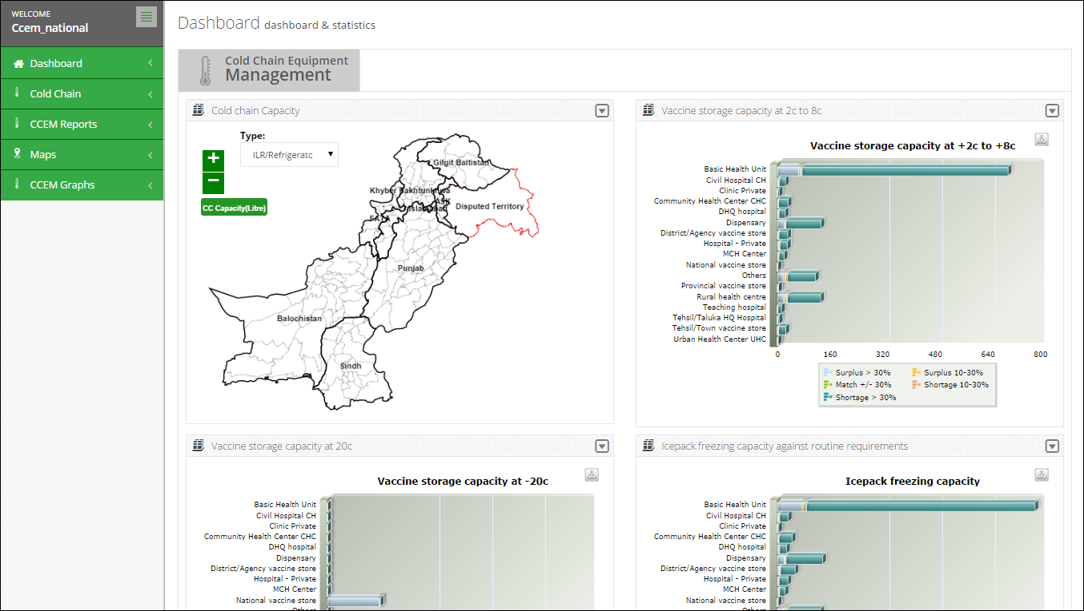**

On the left side of the dashboard screen, the CCEM operator at the national level will see the following tabs:

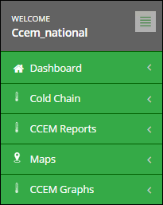

User can sign out of the application by using the following link on the right side of the screen.

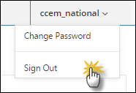

The CCEM National level operator screen includes the following features:

* **Dashboard**: User can view CCEM dashboard containing graphs, maps and analytical reports by using this tab.
* **CCEM**: enables the account user to report the cold chain asset’s status of the assigned warehouse/stores, which helps identify the working condition of the cold-chain machine.
* **CCEM Reports**: user can view the data analysis reports for cold chain equipment. Refer to the “CCEM Reports” section for details.
* **CCEM Graphs:** user can view CCEM graphs for analyzing data. Refer to the “CCEM Graphs” section for details.
* **Maps:** enables user to view the geographical map for Cold-chain capacity.

### **Dashboard**

Dashboard is a visual display of the most important information needed to achieve one or more objectives; consolidated and arranged on a single screen so the information can be monitored at a glance.

For CCEM users, dashboard for cold chain equipment management will be available. User can view the dashboard at three level as shown below:

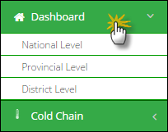

**Cold Chain Equipment Management**

Cold Chain Equipment Management dashboard allows users to view the cold chain capacity map by clicking on this tab.

* **Cold Chain Capacity**

This map shows a map highlighting the cold chain capacity of each district.

* **Vaccine storage capacity at +2c to +8c**

To show the storage capacity of vaccines at certain temperature range within selected health facilities.

* **Vaccine storage capacity at +20c**

To show the storage capacity of vaccines at 20 degrees centigrade within selected health facilities.

* **Icepack freezing capacity against routine requirements**

To show the icepack freezing capacity within selected health facilities.

**Cold Chain Capacity**

Cold Chain Capacity will be displayed through map.

The user can choose product from the drop-down menu.

* ILR/Refrigerators
* Cold Rooms

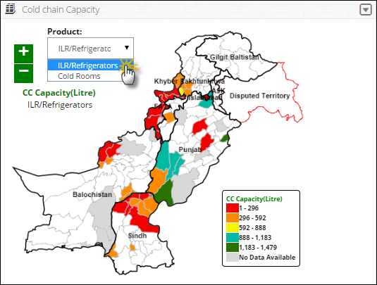

**Vaccine Storage Capacity at +2c to +8c**

Vaccine Storage Capacity at +2c to +8c will be displayed in the form of a bar graph. The user can view the health facilities list on the vertical axis while the capacity range is shown on the horizontal axis.

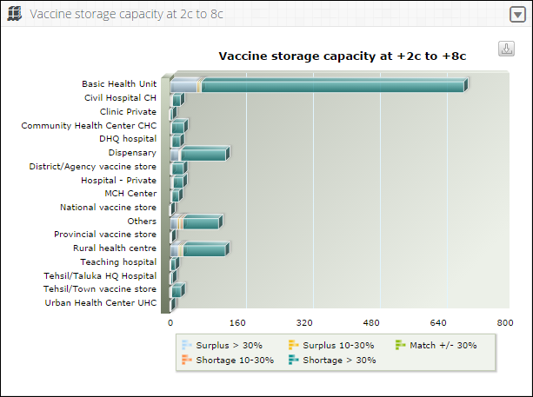

**Vaccine Storage Capacity at +20c**

Vaccine Storage Capacity at +20c will be displayed in the form of a bar graph. The user can view the health facilities list on the vertical axis while the capacity range is shown on the horizontal axis.

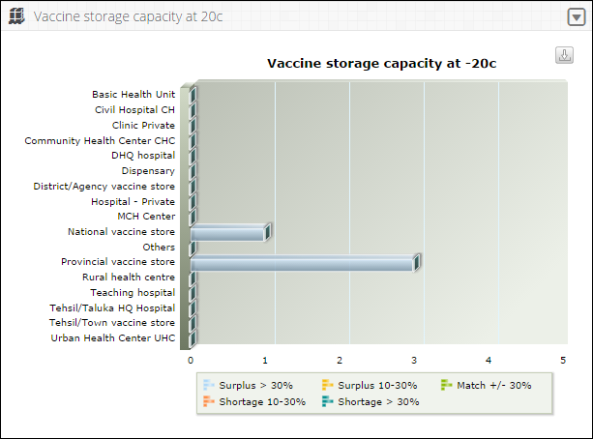

**Icepack freezing capacity against routine requirements**

Cold chain equipment management dashboard will also display icepack freezing capacity graph against routine requirements in the form of a bar graph. The user can view the health facilities list on the vertical axis while the capacity range is shown on the horizontal axis.

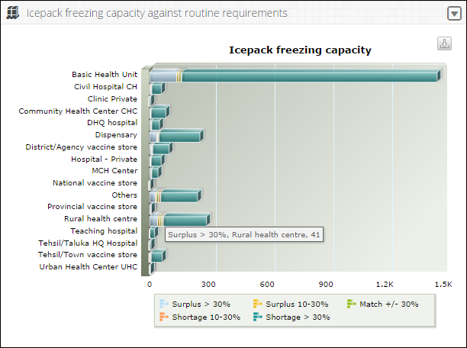

### **Cold Chain**

Click **Cold Chain** from the main menu to display a list of options.

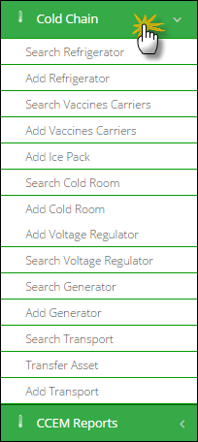

**Introduction to Cold chain Assets**

In vLMIS, cold-chain assets can be divided into two main categories:

1. Registered (Non-quantifiable Assets)
2. Non-Registered (Quantifiable Assets)

Registered assets are those assets which are not added with mentioned quantity. Non-registered assets on the other hand, will consist of a defined quantity.

Currently, there are seven types of cold-chain assets in the vLMIS. All these assets fall into the above mentioned categories.

**Registered Assets**

1. Refrigerators
2. Cold Room
3. Generator
4. Transport

**Non-Registered Assets**

1. Vaccine Carriers
2. Ice Pack
3. Voltage Regulator

Among the registered assets, refrigerators and cold rooms consist of temperature alarms to ensure that the set temperature levels are achieved for vaccines. Generator and transport do not require temperature regulation.

**Add Refrigerator**

To add a new refrigerator:

1. Sign in to the User account.  
   User Home Page displays.
2. Under **CCEM**, click **Add Refrigerator.**  
   New/Add Refrigerator/Freezer/ILR Asset Page displays.
3. Specify the following filters:
   * **Asset ID/Equipment Code:** is an automatically generated unique identifier for the adjustment.
   * **Source of Supply:** select the supplier source from the list.
   * **Utilization:** select the utilization of the asset.
   * **Working Status**: select the status of the Asset from the list.
   * **Placed at**: Specify one of the following:

**Unallocated**: specifies that the asset is not allocated.

**Warehouse**: select the warehouse to place the asset.

* **Office**: In this drop-down, select the office to which you want to issue the asset. On selecting the **Office** level, specify the office location in the adjacent drop-down list. On selecting the location, the **Issue To** drop-down displays the relevant warehouse store names in the selected province. Select the required warehouse/store.
  + **Catalogue ID:** select the Catalogue ID from the list. You can also add a new catalogue ID by clicking **Add.** It will display a new window with following options:
* **Catalogue ID:** specify the Catalogue ID.
* **Make:** specify the make of the asset being added.
* **Model:** specify the model of the asset being added.
* **Asset Sub-Type**: Select asset sub-type from the list.
* **Dimensions**: Add the dimensions of the asset in feet.
* **Capacity:** Add the capacity of the asset in liters.
* **CFC Free Sticker:** select one of the options from Not Applicable, Yes and No.
  + **Serial No**.: Enter the asset’s serial number.
  + **Working Since (Year)**: Enter the year since the working of the asset.

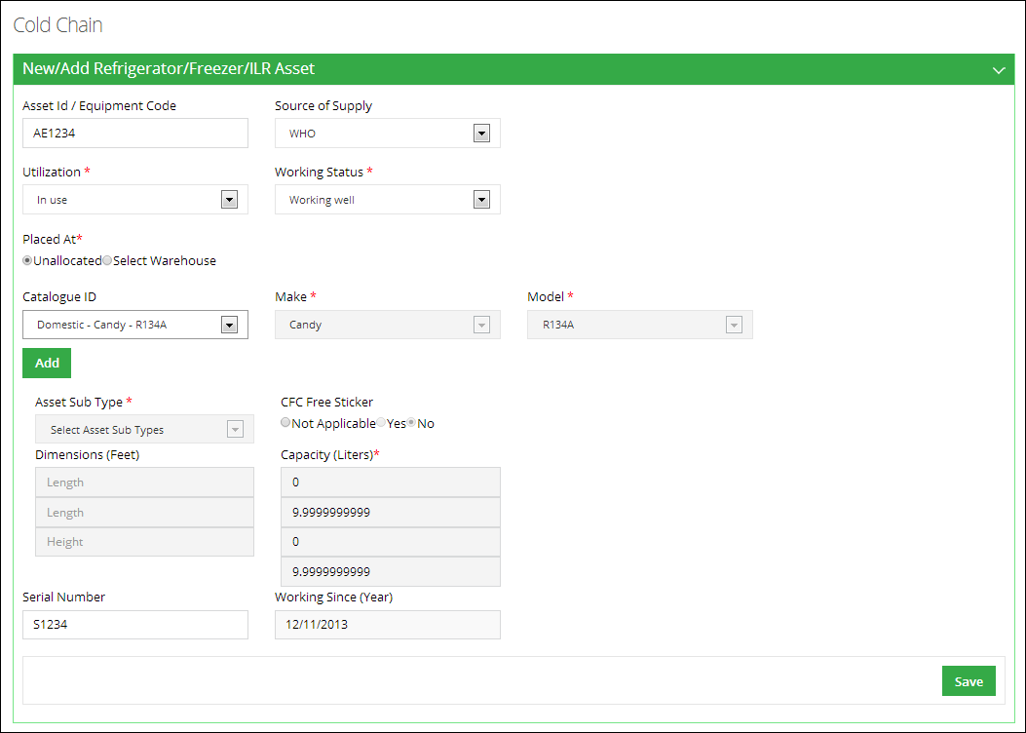

1. Click **Save** to save the new asset.

**Search Refrigerator**

To search a refrigerator:

1. Sign in to the User account.  
   User Home Page displays.
2. Under **CCEM**, click **Search Refrigerator.**  
   Search Refrigerator/Freezer/ILR Asset Page displays.
3. Specify the following filters:
   * **Asset Sub-Type:** Select asset sub-type from the list.
   * **Source of Supply:** select the supplier source from the list.
   * **Working Status**: select the status of the Asset from the list.
   * **Asset ID/Equipment Code:** is an automatically generated unique identifier for the adjustment.
   * **Catalogue ID:** specify the Catalogue ID.
   * **Make:** specify the make of the asset being added.
   * **Model:** specify the model of the asset being added.
   * **Serial No**.: Enter the asset’s serial number.
   * **Gross Capacity From:** Add the gross capacity of the asset in liters.
   * **Gross Capacity to:** Add the gross capacity of the asset in liters.
   * **Working From:** Enter the year since the working of the asset.
   * **Working To:** Enter the year till the optimal working of the asset.
   * **CFC Free Sticker:** select one of the options from Not Applicable, Yes and No.
   * **Placed at**: Specify one of the following:

**Unallocated**: specifies that the asset is not allocated.

**Warehouse**: select the warehouse to place the asset.

* **Office**: In this drop-down, select the office to which you want to issue the asset. On selecting the **Office** level, specify the office location in the adjacent drop-down list. On selecting the location, the **Issue To** drop-down displays the relevant warehouse store names in the selected province. Select the required warehouse/store.
  + **Working Since (Year)**: Enter the year since the working of the asset.

1. Click **Search.**

**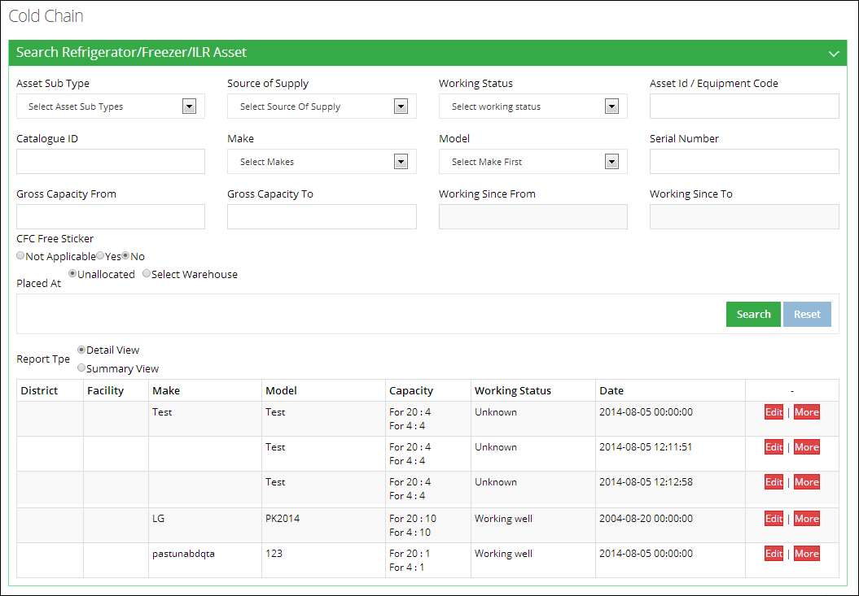**

1. **Report Type:** select the report type such as summary view or detail view.

**Add Vaccine Carriers**

To add a new vaccine carrier:

1. Sign in to the User account.  
   User Home Page displays.
2. Under **CCEM**, click **Add Vaccine Carriers.**  
   Add Vaccine Carriers Page displays.
3. Specify the following filters:
   * **Placed at**: Specify one of the following:

**Unallocated**: specifies that the asset is not allocated.

**Warehouse**: select the warehouse to place the asset.

* **Office**: In this drop-down, select the office to which you want to issue the asset. On selecting the **Office** level, specify the office location in the adjacent drop-down list. On selecting the location, the **Issue To** drop-down displays the relevant warehouse store names in the selected province. Select the required warehouse/store.
  + **Catalogue ID:** select the Catalogue ID from the list. You can also add a new catalogue ID by clicking **Add.** It will display a new window with following options:
* **Catalogue ID:** specify the Catalogue ID.
* **Make:** specify the make of the asset being added.
* **Model:** specify the model of the asset being added.
* **Dimensions**: Add the dimensions of the asset in feet.

1. Add **Total Available for Vaccination Activities** and click **Save.**

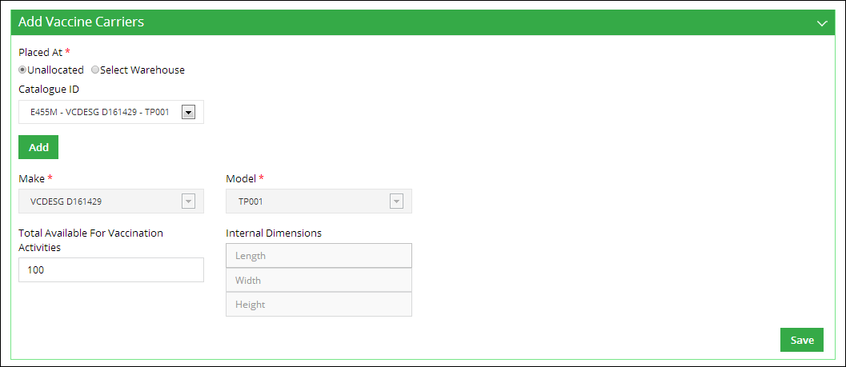

**Search Vaccine Carriers**

To search a vaccine carrier:

1. Sign in to the User account.  
   User Home Page displays.
2. Under **CCEM**, click **Search Vaccine Carriers.**  
   Vaccine Carrier Search Page displays.
3. Specify the following filters:
   1. **Catalogue ID:** specify the Catalogue ID.
   2. **Make:** specify the make of the asset being added.
   3. **Model:** specify the model of the asset being added.
   4. **Placed at**: Specify one of the following:

**Unallocated**: specifies that the asset is not allocated.

**Warehouse**: select the warehouse to place the asset.

* **Office**: In this drop-down, select the office to which you want to issue the asset. On selecting the **Office** level, specify the office location in the adjacent drop-down list. On selecting the location, the **Issue To** drop-down displays the relevant warehouse store names in the selected province. Select the required warehouse/store.

1. Click **Search.**

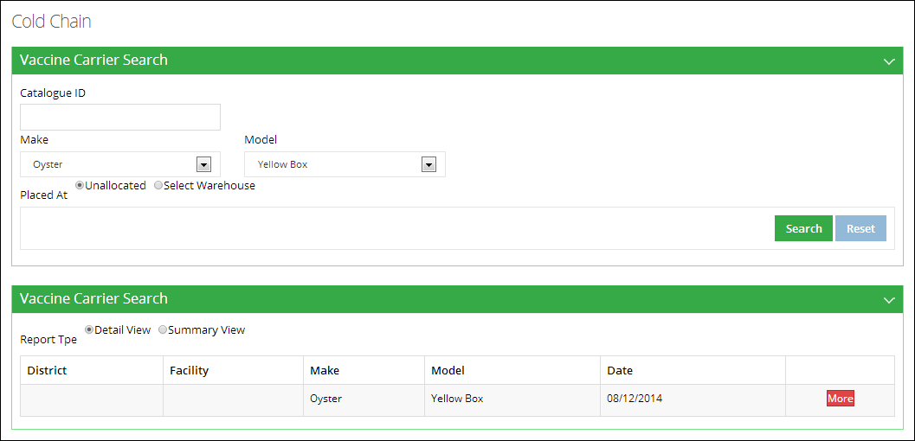

1. **Report Type:** select the report type such as summary view or detail view.

**Add Ice Packs**

To add ice packs:

1. Sign in to the User account.  
   User Home Page displays.
2. Under **CCEM**, click **Add Ice Packs.**  
   Add Ice Packs Page displays.
3. Specify the following filters:
   * **Placed at**: Specify one of the following:

**Unallocated**: specifies that the asset is not allocated.

**Warehouse**: select the warehouse to place the asset.

* **Office**: In this drop-down, select the office to which you want to issue the asset. On selecting the **Office** level, specify the office location in the adjacent drop-down list. On selecting the location, the **Issue To** drop-down displays the relevant warehouse store names in the selected province. Select the required warehouse/store.

1. Add **Quantity** before the ice pack size required to be added.
2. Click **Add.**

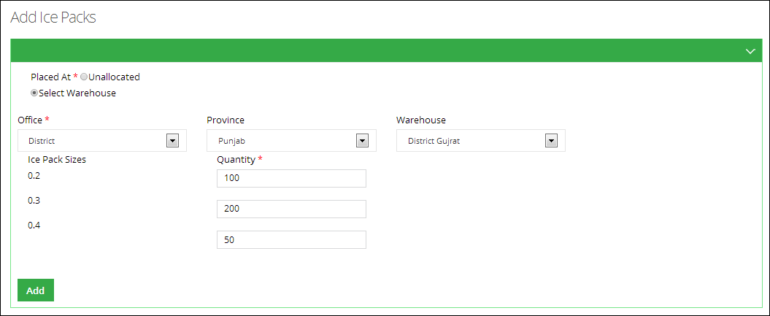

**Search Ice Pack**

To search an ice pack:

1. Sign in to the User account.  
   User Home Page displays.
2. Under **CCEM**, click **Search Ice Pack.**  
   Ice Pack Search Page displays.
3. Specify the following filters:
   1. **Make:** specify the make of the asset being added.
   2. **Model:** specify the model of the asset being added.
   3. **Placed at**: Specify one of the following:

**Unallocated**: specifies that the asset is not allocated.

**Warehouse**: select the warehouse to place the asset.

* **Office**: In this drop-down, select the office to which you want to issue the asset. On selecting the **Office** level, specify the office location in the adjacent drop-down list. On selecting the location, the **Issue To** drop-down displays the relevant warehouse store names in the selected province. Select the required warehouse/store.

1. Click **Search.**

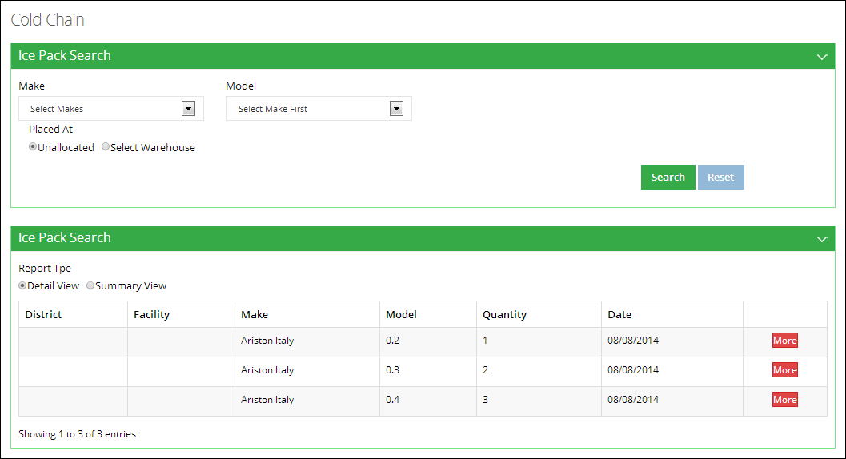

1. **Report Type:** select the report type such as summary view or detail view.

**Add Cold Room**

To add a cold room:

1. Sign in to the User account.  
   User Home Page displays.
2. Under **CCEM**, click **Add Cold Room.**  
   Add Cold Room Page displays.
3. Specify the following filters:
   * **Asset ID/Equipment Code:** is an automatically generated unique identifier for the asset.
   * **Source of Supply:** select the supplier source from the list.
   * **Utilization:** select the utilization of the cold room.
   * **Working Status**: select the status of the cold room from the list.
   * **Placed at**: Specify one of the following:

**Unallocated**: specifies that the cold room is not allocated.

**Warehouse**: select the warehouse to place the cold room.

* **Office**: In this drop-down, select the office to which you want to issue the asset. On selecting the **Office** level, specify the office location in the adjacent drop-down list. On selecting the location, the **Issue To** drop-down displays the relevant warehouse store names in the selected province. Select the required warehouse/store.
  + **Type:** select the type of the cold room.
  + **Internal Storage Dimensions:** specify the storage dimensions of the cold room such as length, width and height.
* **Make:** specify the make of the cold room being added.
* **Model:** specify the model of the asset being added.
* **Internal gross volume:** specify in meters.
* **Net storage volume for vaccine/packs:** specify the volume in meters.
* **Year of Supply:** specify the year of supply for the cold room.
* **Number of cooling system:** specify the number of cooling systems in the cold room.
* **Number of phases:** select the number of phases.
* **Refrigerator gas type:** select the type of refrigerator gas.
* Specify if there is a **Voltage Stabilizer** or not.
* Specify if the cold room **has working backup generator**.
* **Temperature recording system:** select the temperature recording system from the list.
* **Type of recording system:** select the type of recording system.

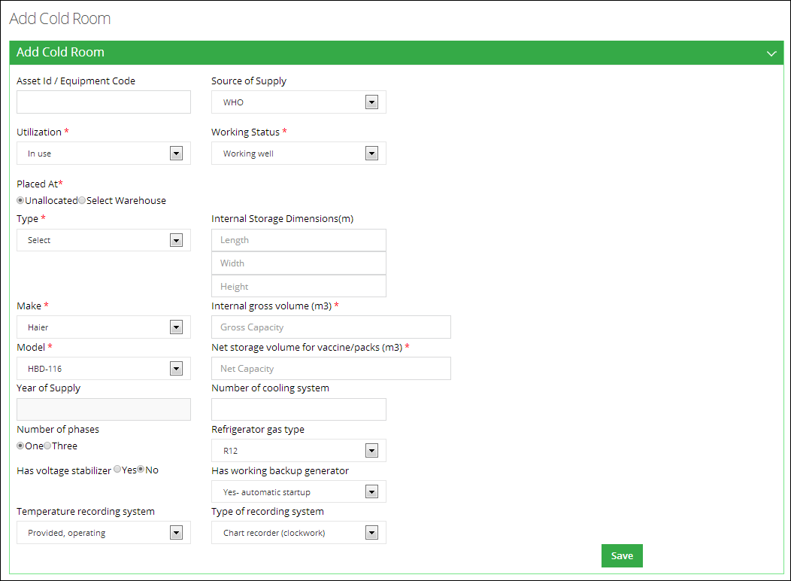

1. Click **Save** to save the new cold room.

A new cold room would be added.

**Search Cold Room**

To search a cold room:

1. Sign in to the User account.  
   User Home Page displays.
2. Under **CCEM**, click **Search Cold Room.**  
   Cold Room Search Page displays.
3. Specify the following filters:

* **Type:** select the type of the cold room.
* **Working Status:** select the status of the cold room from the list.
* **Source of Supply:** select the supplier source from the list.
* **Number of cooling system:** specify the number of cooling systems in the cold room.
* **Asset ID/Equipment Code:** is an automatically generated unique identifier for the asset.
* Specify if there is a **Voltage Stabilizer** or not.
* **Make:** specify the make of the cold room being added.
* **Model:** specify the model of the asset being added.
* **Capacity From, Capacity to:** Add the capacity of the cold room.
* **Year of Supply From, to:** specify the year of supply for the cold room.
* **Placed at**: Specify one of the following:

**Unallocated**: specifies that the cold room is not allocated.

**Warehouse**: select the warehouse to place the cold room.

* **Office**: In this drop-down, select the office to which you want to issue the asset. On selecting the **Office** level, specify the office location in the adjacent drop-down list. On selecting the location, the **Issue To** drop-down displays the relevant warehouse store names in the selected province. Select the required warehouse/store.

1. Click **Search.**

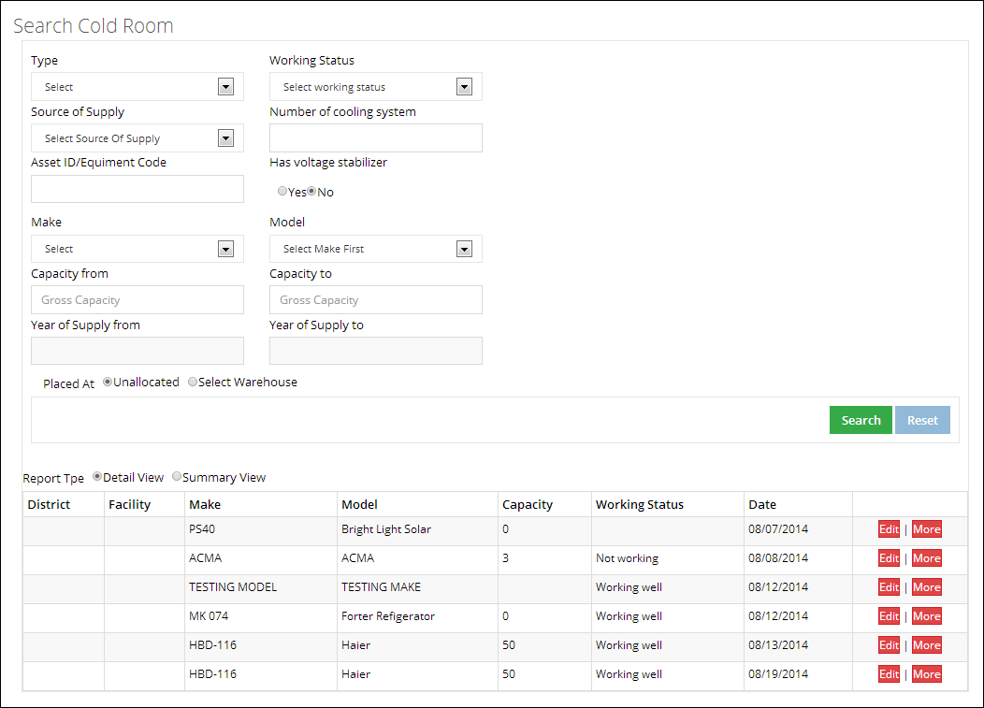

1. **Report Type:** select the report type such as summary view or detail view.

**Add Voltage Regulator**

To add a voltage regulator:

1. Sign in to the User account.  
   User Home Page displays.
2. Under **CCEM**, click **Add Voltage Regulator.**  
   Add Voltage Regulator Page displays.
3. Specify the following filters:
   * **Placed at**: Specify one of the following:

**Unallocated**: specifies that the voltage regulator is not allocated.

**Warehouse**: select the warehouse to place the regulator.

* **Office**: In this drop-down, select the office to which you want to issue the asset. On selecting the **Office** level, specify the office location in the adjacent drop-down list. On selecting the location, the **Issue To** drop-down displays the relevant warehouse store names in the selected province. Select the required warehouse/store.

1. **Catalogue ID:** specify the Catalogue ID.
2. Add **Quantity** before the ice pack size required to be added.
3. Click **Add.**

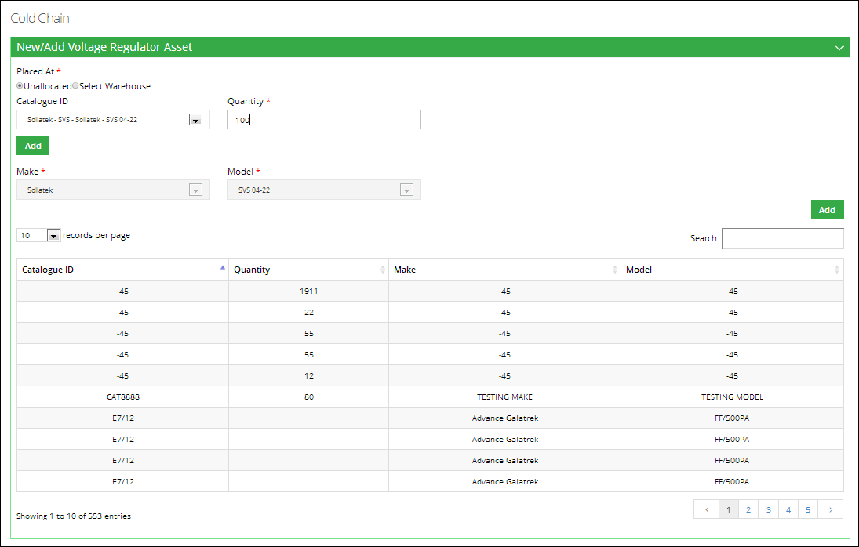

1. User can also search a specific regulator from the list.

**Search Voltage Regulator**

To search a voltage regulator:

1. Sign in to the User account.  
   User Home Page displays.
2. Under **CCEM**, click **Search Voltage Regulator.**  
   Search Voltage Regulator Page displays.
3. **Catalogue ID:** specify the Catalogue ID.
4. **Make:** specify the make of the voltage regulator.
5. **Model:** specify the model of the voltage regulator.
6. Specify the following filters:
   * **Placed at**: Specify one of the following:

**Unallocated**: specifies that the voltage regulator is not allocated.

**Warehouse**: select the warehouse to place the regulator.

* **Office**: In this drop-down, select the office to which you want to issue the asset. On selecting the **Office** level, specify the office location in the adjacent drop-down list. On selecting the location, the **Issue To** drop-down displays the relevant warehouse store names in the selected province. Select the required warehouse/store.

1. **Catalogue ID:** specify the Catalogue ID.
2. Add **Quantity** before the ice pack size required to be added.
3. Click **Search.**

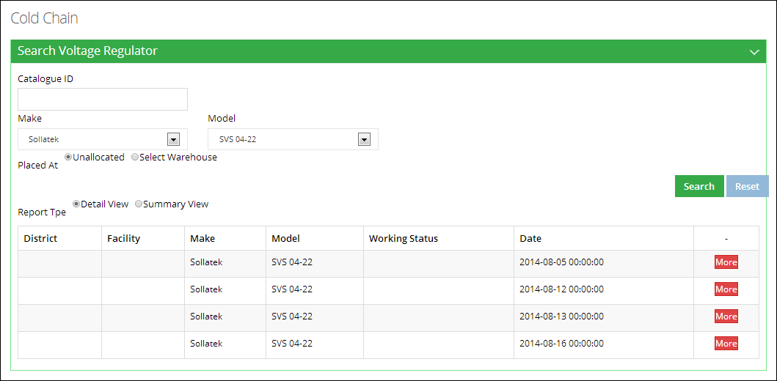

1. **Report Type:** select the report type such as summary view or detail view.

**Add Generator**

To add a new generator:

1. Sign in to the User account.  
   User Home Page displays.
2. Under **CCEM**, click **Add Generator.**  
   Add Generator Page displays.
3. Specify the following filters:
   * **Asset ID/Equipment Code:** is an automatically generated unique identifier for the adjustment.
   * **Source of Supply:** select the supplier source from the list.
   * **Utilization:** select the utilization of the asset.
   * **Working Status**: select the status of the Asset from the list.
   * **Placed at**: Specify one of the following:

**Unallocated**: specifies that the asset is not allocated.

**Warehouse**: select the warehouse to place the asset.

* **Office**: In this drop-down, select the office to which you want to issue the asset. On selecting the **Office** level, specify the office location in the adjacent drop-down list. On selecting the location, the **Issue To** drop-down displays the relevant warehouse store names in the selected province. Select the required warehouse/store.
  + **Make:** specify the make of the asset being added.
  + **Model:** specify the model of the asset being added.
  + **Serial No**.: Enter the asset’s serial number.
  + **Number of phases:** select the number of phases.
  + **Power Rating:** Enter the power rating of the generator.
  + **Power Source:** Select the power source of the generator.
  + Specify if the generator has an **Automatic Start Mechanism** or not.
  + **Year of Supply:** specify the year of supply for the generator.
  + **Use for:** select the use for the generator.

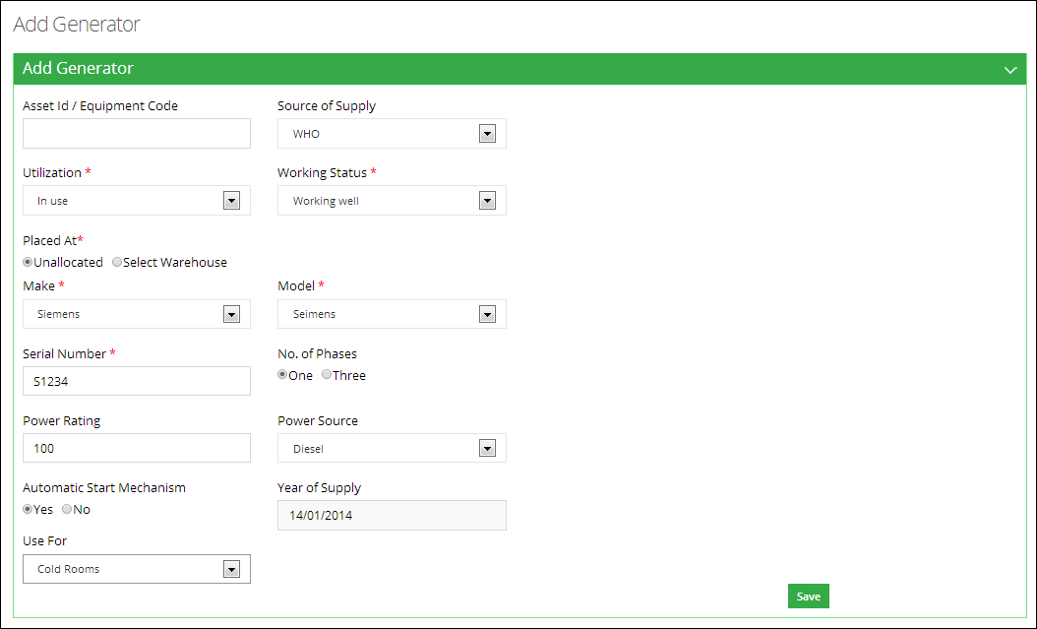

1. Click **Save** to save the new generator.

**Search Generator**

To search a generator:

1. Sign in to the User account.  
   User Home Page displays.
2. Under **CCEM**, click **Search Generator.**  
   Search Generator Page displays.
3. Specify the following filters:
   * **Working Status**: select the status of the Asset from the list.
   * **Source of Supply:** select the supplier source from the list.
   * **Asset ID/Equipment Code:** is an automatically generated unique identifier for the adjustment.
   * **Make:** specify the make of the asset being added.
   * **Model:** specify the model of the asset being added.
   * **Year of Supply from, to:** specify the year of supply for the generator.
   * **Placed at**: Specify one of the following:

**Unallocated**: specifies that the asset is not allocated.

**Warehouse**: select the warehouse to place the asset.

* **Office**: In this drop-down, select the office to which you want to issue the asset. On selecting the **Office** level, specify the office location in the adjacent drop-down list. On selecting the location, the **Issue To** drop-down displays the relevant warehouse store names in the selected province. Select the required warehouse/store.

1. Click **Search.**

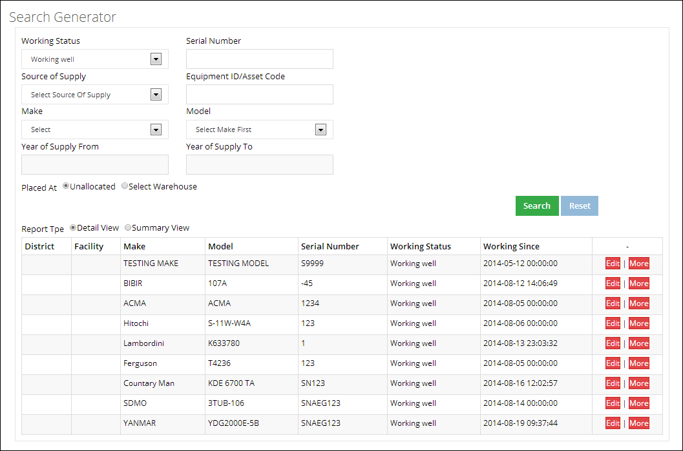

1. **Report Type:** select the report type such as summary view or detail view.

**Add Transport**

To add a new transport:

1. Sign in to the User account.  
   User Home Page displays.
2. Under **CCEM**, click **Add Transport.**  
   Add Transport Page displays.
3. Specify the following filters:
   * **Asset ID/Equipment Code:** is an automatically generated unique identifier for the transport.
   * **Source of Supply:** select the supplier source from the list.
   * **Utilization:** select the utilization of the.
   * **Working Status**: select the status of the transport from the list.
   * **Placed at**: Specify one of the following:

**Unallocated**: specifies that the transport is not allocated.

**Warehouse**: select the warehouse to place the transport.

* **Office**: In this drop-down, select the office to which you want to issue the asset. On selecting the **Office** level, specify the office location in the adjacent drop-down list. On selecting the location, the **Issue To** drop-down displays the relevant warehouse store names in the selected province. Select the required warehouse/store.
  + **Transport Type:** select the transport type.
  + **Registration No.:** specify the registration number. This field is optional.
  + **Make:** specify the make of the transport being added.
  + **Model:** specify the model of the transport being added.
  + **Manufacture Year:** select the manufacture year of the transport.
  + **% use for EPI:** specify the percent use for EPI. This is an optional field.
  + **Fuel Type:** select the fuel type being used.

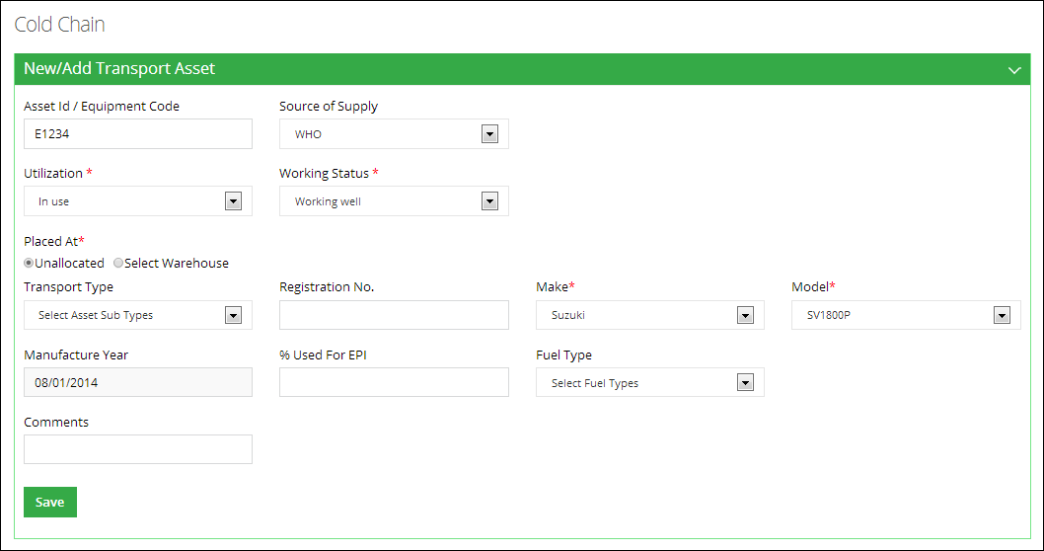

1. Click **Save** to save the new transport.

**Search Transport**

To search a transport:

1. Sign in to the User account.  
   User Home Page displays.
2. Under **CCEM**, click **Search Transport.**  
   Search Transport Page displays.
3. Specify the following filters:
   * **Transport Type:** select the transport type.
   * **Working Status**: select the status of the Asset from the list.
   * **Source of Supply:** select the supplier source from the list.
   * **Fuel Type:** select the fuel type being used.
   * **Registration No.:** specify the registration number. This field is optional.
   * **Make:** specify the make of the asset being added.
   * **Model:** specify the model of the asset being added.
   * **Manufacture Year from, to:** specify the year of manufacture for the tranport.
   * **Placed at**: Specify one of the following:

**Unallocated**: specifies that the asset is not allocated.

**Warehouse**: select the warehouse to place the asset.

* **Office**: In this drop-down, select the office to which you want to issue the asset. On selecting the **Office** level, specify the office location in the adjacent drop-down list. On selecting the location, the **Issue To** drop-down displays the relevant warehouse store names in the selected province. Select the required warehouse/store.

1. Click **Search.**

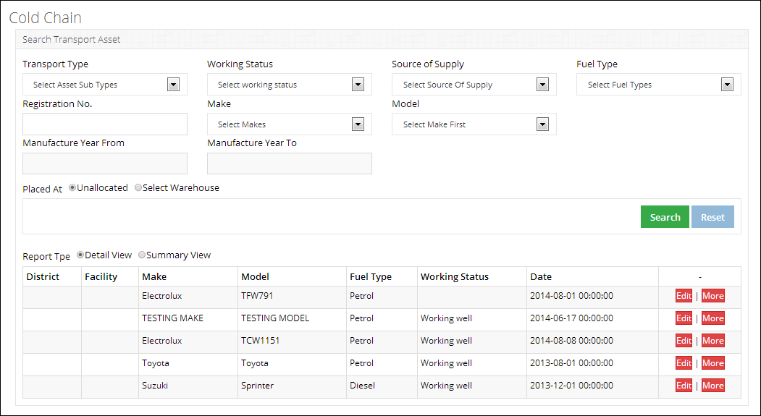

1. **Report Type:** select the report type such as summary view or detail view.

**Transfer Asset**

To transfer an Asset:

1. Sign in to the User account.  
   The User Home Page displays.
2. Click **Transfer Asset** under **CCEM**.  
   The Transfer Asset page displays.
3. In **From Office**, select the office.  
     
   **Office**: In this drop-down, select the office. On selecting the **Office** level, specify the office location in the adjacent drop-down list. On selecting the location, the drop-down displays the relevant warehouse store names in the selected province. Select the required warehouse/store.

The Asset’s details are displayed.

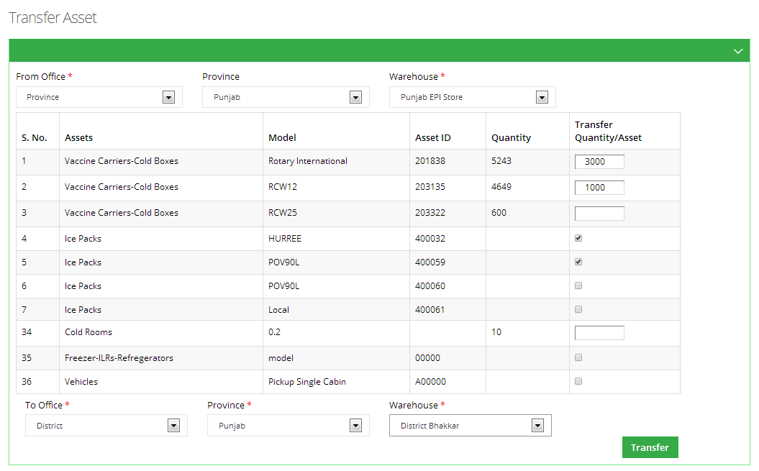

1. In **Transfer Quantity/Asset,** specify the quantity you want to transfer.



In **To Office,** specify the location that you want to transfer to.  
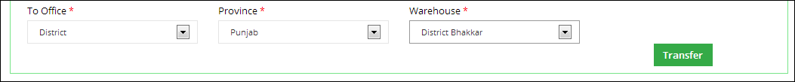

1. Click **Transfer**.

### **Maps**

The LMIS also has the capability of generating easy to interpret maps with color codes. These interactive maps would be made available through the Government of Pakistan website and help in increasing the use of the existing information disseminates by Government of Pakistan through the web-based vLMIS by providing the information a more captivating approach to both promote the importance of supply chain and use of data in decision making.

This application is helpful for the health managers at all levels of administrative tiers for planning, identification of possible supply chain problems and new areas of improvements. In addition, GIS dashboards combined with other reports and graphs of vLMIS application give quick overview of monthly situation of commodities and reporting status. This is a good epidemiological tool to combine outputs of web-mapping application with other sources for data for research activities.

CCEM operators can view cold-chain capacity map by using the Maps tab from the main menu. Once the cold-chain indicator for which the map is to be viewed is selected, the user will be directed towards a page to select from various filters.

**Cold Chain Capacity Map**

This map shows the cold-chain capacity of each district within the selected province. User can see filter options such as Province/Region and Type of refrigerators or cold rooms to analyze the cold chain capacity rate for each district in the selected province based on the number of facilities in that district. The detailed information can be seen once the user clicks a particular district on the map.

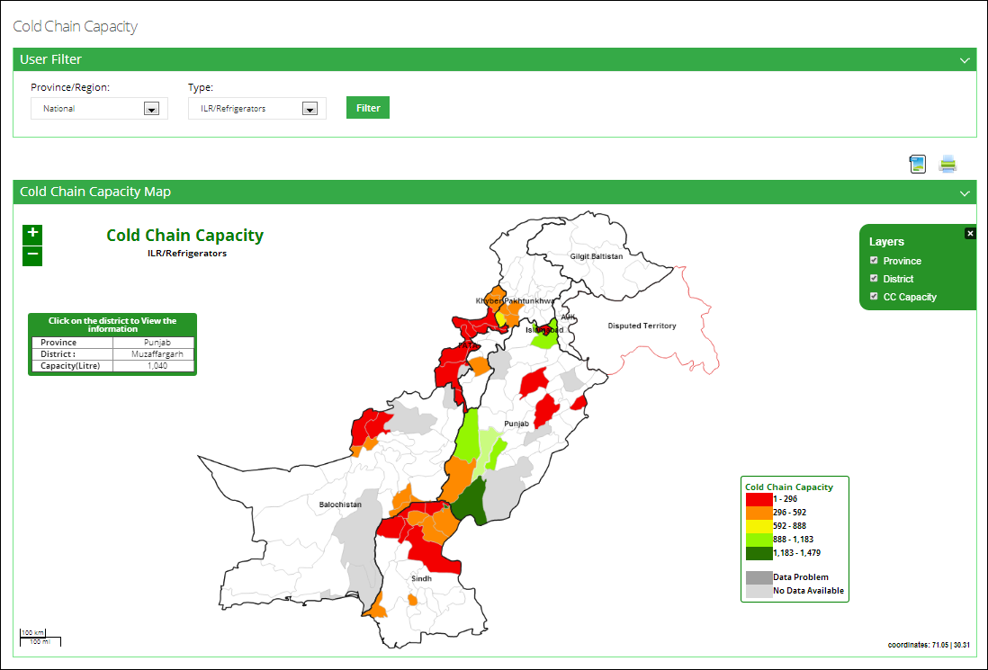

### 

### **CCEM Reports**

Refer to the “CCEM Reports” section of the user manual.

### **CCEM Graphs**

Refer to the “CCEM Graphs” section of the user manual.

## **Provincial CCEM Operator**

It is essential for the effectiveness of the vaccines that an unbroken cold chain with an uninterrupted series of storage and distribution activities is maintained for the given temperature range. Logging in to the Provincial User account displays the account’s Home page screen by default.

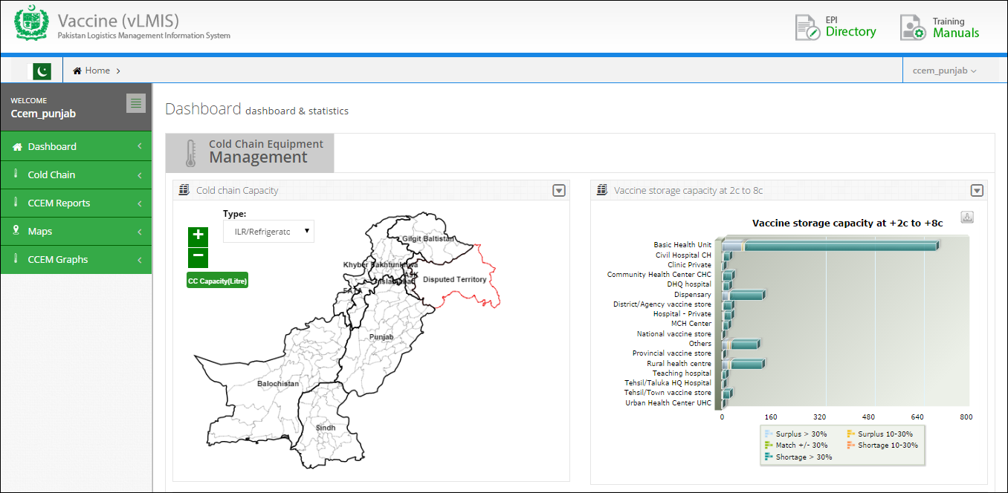

On the left side of the dashboard screen, the CCEM operator at the provincial level will see the following tabs:

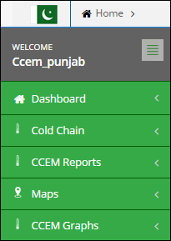

User can sign out of the application by using the following link on the right side of the screen.

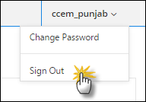

The CCEM Provincial level operator screen includes the following features:

* **Dashboard**: User can view CCEM dashboard containing graphs, maps and analytical reports by using this tab.
* **CCEM**: enables the account user to report the cold chain asset’s status of the assigned warehouse/stores, which helps identify the working condition of the cold-chain machine.
* **CCEM Reports**: user can view the data analysis reports for cold chain equipment. Refer to the “CCEM Reports” section for details.
* **CCEM Graphs:** user can view CCEM graphs for analyzing data. Refer to the “CCEM Graphs” section for details.
* **Maps:** enables user to view the geographical map for Cold-chain capacity.

### **Dashboard**

Dashboard is a visual display of the most important information needed to achieve one or more objectives; consolidated and arranged on a single screen so the information can be monitored at a glance.

For CCEM users, dashboard for cold chain equipment management will be available. User can view the dashboard at three level as shown below:

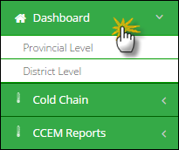

**Cold Chain Equipment Management**

Cold Chain Equipment Management dashboard allows users to view the cold chain capacity map by clicking on this tab.

* **Cold Chain Capacity**

This map shows a map highlighting the cold chain capacity of each district.

* **Vaccine storage capacity at +2c to +8c**

To show the storage capacity of vaccines at certain temperature range within selected health facilities.

* **Vaccine storage capacity at +20c**

To show the storage capacity of vaccines at 20 degrees centigrade within selected health facilities.

* **Icepack freezing capacity against routine requirements**

To show the icepack freezing capacity within selected health facilities.

**Cold Chain Capacity**

Cold Chain Capacity will be displayed through map.

The user can choose product from the drop-down menu.

* ILR/Refrigerators
* Cold Rooms



**Vaccine Storage Capacity at +2c to +8c**

Vaccine Storage Capacity at +2c to +8c will be displayed in the form of a bar graph. The user can view the health facilities list on the vertical axis while the capacity range is shown on the horizontal axis.



**Vaccine Storage Capacity at +20c**

Vaccine Storage Capacity at +20c will be displayed in the form of a bar graph. The user can view the health facilities list on the vertical axis while the capacity range is shown on the horizontal axis.



**Icepack freezing capacity against routine requirements**

Cold chain equipment management dashboard will also display icepack freezing capacity graph against routine requirements in the form of a bar graph. The user can view the health facilities list on the vertical axis while the capacity range is shown on the horizontal axis.



### **Cold Chain**

Click **Cold Chain** from the main menu to display a list of options.



**Add Refrigerator**

To add a new refrigerator:

1. Sign in to the User account.  
   User Home Page displays.
2. Under **CCEM**, click **Add Refrigerator.**  
   New/Add Refrigerator/Freezer/ILR Asset Page displays.
3. Specify the following filters:
   * **Asset ID/Equipment Code:** is an automatically generated unique identifier for the adjustment.
   * **Source of Supply:** select the supplier source from the list.
   * **Utilization:** select the utilization of the asset.
   * **Working Status**: select the status of the Asset from the list.
   * **Placed at**: Specify one of the following:

**Unallocated**: specifies that the asset is not allocated.

**Warehouse**: select the warehouse to place the asset.

* **Office**: In this drop-down, select the office to which you want to issue the asset. On selecting the **Office** level, specify the office location in the adjacent drop-down list. On selecting the location, the **Issue To** drop-down displays the relevant warehouse store names in the selected province. Select the required warehouse/store.
  + **Catalogue ID:** select the Catalogue ID from the list. You can also add a new catalogue ID by clicking **Add.** It will display a new window with following options:
* **Catalogue ID:** specify the Catalogue ID.
* **Make:** specify the make of the asset being added.
* **Model:** specify the model of the asset being added.
* **Asset Sub-Type**: Select asset sub-type from the list.
* **Dimensions**: Add the dimensions of the asset in feet.
* **Capacity:** Add the capacity of the asset in liters.
* **CFC Free Sticker:** select one of the options from Not Applicable, Yes and No.
  + **Serial No**.: Enter the asset’s serial number.
  + **Working Since (Year)**: Enter the year since the working of the asset.



1. Click **Save** to save the new asset.

**Search Refrigerator**

To search a refrigerator:

1. Sign in to the User account.  
   User Home Page displays.
2. Under **CCEM**, click **Search Refrigerator.**  
   Search Refrigerator/Freezer/ILR Asset Page displays.
3. Specify the following filters:
   * **Asset Sub-Type:** Select asset sub-type from the list.
   * **Source of Supply:** select the supplier source from the list.
   * **Working Status**: select the status of the Asset from the list.
   * **Asset ID/Equipment Code:** is an automatically generated unique identifier for the adjustment.
   * **Catalogue ID:** specify the Catalogue ID.
   * **Make:** specify the make of the asset being added.
   * **Model:** specify the model of the asset being added.
   * **Serial No**.: Enter the asset’s serial number.
   * **Gross Capacity From:** Add the gross capacity of the asset in liters.
   * **Gross Capacity to:** Add the gross capacity of the asset in liters.
   * **Working From:** Enter the year since the working of the asset.
   * **Working To:** Enter the year till the optimal working of the asset.
   * **CFC Free Sticker:** select one of the options from Not Applicable, Yes and No.
   * **Placed at**: Specify one of the following:

**Unallocated**: specifies that the asset is not allocated.

**Warehouse**: select the warehouse to place the asset.

* **Office**: In this drop-down, select the office to which you want to issue the asset. On selecting the **Office** level, specify the office location in the adjacent drop-down list. On selecting the location, the **Issue To** drop-down displays the relevant warehouse store names in the selected province. Select the required warehouse/store.
  + **Working Since (Year)**: Enter the year since the working of the asset.

1. Click **Search.**

****

1. **Report Type:** select the report type such as summary view or detail view.

**Add Vaccine Carriers**

To add a new vaccine carrier:

1. Sign in to the User account.  
   User Home Page displays.
2. Under **CCEM**, click **Add Vaccine Carriers.**  
   Add Vaccine Carriers Page displays.
3. Specify the following filters:
   * **Placed at**: Specify one of the following:

**Unallocated**: specifies that the asset is not allocated.

**Warehouse**: select the warehouse to place the asset.

* **Office**: In this drop-down, select the office to which you want to issue the asset. On selecting the **Office** level, specify the office location in the adjacent drop-down list. On selecting the location, the **Issue To** drop-down displays the relevant warehouse store names in the selected province. Select the required warehouse/store.
  + **Catalogue ID:** select the Catalogue ID from the list. You can also add a new catalogue ID by clicking **Add.** It will display a new window with following options:
* **Catalogue ID:** specify the Catalogue ID.
* **Make:** specify the make of the asset being added.
* **Model:** specify the model of the asset being added.
* **Dimensions**: Add the dimensions of the asset in feet.

1. Add **Total Available for Vaccination Activities.**
2. Click **Save.**



**Search Vaccine Carriers**

To search a vaccine carrier:

1. Sign in to the User account.  
   User Home Page displays.
2. Under **CCEM**, click **Search Vaccine Carriers.**  
   Vaccine Carrier Search Page displays.
3. Specify the following filters:
   1. **Catalogue ID:** specify the Catalogue ID.
   2. **Make:** specify the make of the asset being added.
   3. **Model:** specify the model of the asset being added.
   4. **Placed at**: Specify one of the following:

**Unallocated**: specifies that the asset is not allocated.

**Warehouse**: select the warehouse to place the asset.

* **Office**: In this drop-down, select the office to which you want to issue the asset. On selecting the **Office** level, specify the office location in the adjacent drop-down list. On selecting the location, the **Issue To** drop-down displays the relevant warehouse store names in the selected province. Select the required warehouse/store.

1. Click **Search.**



1. **Report Type:** select the report type such as summary view or detail view.

**Add Ice Packs**

To add ice packs:

1. Sign in to the User account.  
   User Home Page displays.
2. Under **CCEM**, click **Add Ice Packs.**  
   Add Ice Packs Page displays.
3. Specify the following filters:
   * **Placed at**: Specify one of the following:

**Unallocated**: specifies that the asset is not allocated.

**Warehouse**: select the warehouse to place the asset.

* **Office**: In this drop-down, select the office to which you want to issue the asset. On selecting the **Office** level, specify the office location in the adjacent drop-down list. On selecting the location, the **Issue To** drop-down displays the relevant warehouse store names in the selected province. Select the required warehouse/store.

1. Add **Quantity** before the ice pack size required to be added.
2. Click **Add.**



**Search Ice Pack**

To search an ice pack:

1. Sign in to the User account.  
   User Home Page displays.
2. Under **CCEM**, click **Search Ice Pack.**  
   Ice Pack Search Page displays.
3. Specify the following filters:
   1. **Make:** specify the make of the asset being added.
   2. **Model:** specify the model of the asset being added.
   3. **Placed at**: Specify one of the following:

**Unallocated**: specifies that the asset is not allocated.

**Warehouse**: select the warehouse to place the asset.

* **Office**: In this drop-down, select the office to which you want to issue the asset. On selecting the **Office** level, specify the office location in the adjacent drop-down list. On selecting the location, the **Issue To** drop-down displays the relevant warehouse store names in the selected province. Select the required warehouse/store.

1. Click **Search.**



1. **Report Type:** select the report type such as summary view or detail view.

**Add Cold Room**

To add a cold room:

1. Sign in to the User account.  
   User Home Page displays.
2. Under **CCEM**, click **Add Cold Room.**  
   Add Cold Room Page displays.
3. Specify the following filters:
   * **Asset ID/Equipment Code:** is an automatically generated unique identifier for the asset.
   * **Source of Supply:** select the supplier source from the list.
   * **Utilization:** select the utilization of the cold room.
   * **Working Status**: select the status of the cold room from the list.
   * **Placed at**: Specify one of the following:

**Unallocated**: specifies that the cold room is not allocated.

**Warehouse**: select the warehouse to place the cold room.

* **Office**: In this drop-down, select the office to which you want to issue the asset. On selecting the **Office** level, specify the office location in the adjacent drop-down list. On selecting the location, the **Issue To** drop-down displays the relevant warehouse store names in the selected province. Select the required warehouse/store.
  + **Type:** select the type of the cold room.
  + **Internal Storage Dimensions:** specify the storage dimensions of the cold room such as length, width and height.
* **Make:** specify the make of the cold room being added.
* **Model:** specify the model of the asset being added.
* **Internal gross volume:** specify in meters.
* **Net storage volume for vaccine/packs:** specify the volume in meters.
* **Year of Supply:** specify the year of supply for the cold room.
* **Number of cooling system:** specify the number of cooling systems in the cold room.
* **Number of phases:** select the number of phases.
* **Refrigerator gas type:** select the type of refrigerator gas.
* Specify if there is a **Voltage Stabilizer** or not.
* Specify if the cold room **has working backup generator**.
* **Temperature recording system:** select the temperature recording system from the list.
* **Type of recording system:** select the type of recording system.



1. Click **Save** to save the new cold room.

A new cold room would be added.

**Search Cold Room**

To search a cold room:

1. Sign in to the User account.  
   User Home Page displays.
2. Under **CCEM**, click **Search Cold Room.**  
   Cold Room Search Page displays.
3. Specify the following filters:

* **Type:** select the type of the cold room.
* **Working Status:** select the status of the cold room from the list.
* **Source of Supply:** select the supplier source from the list.
* **Number of cooling system:** specify the number of cooling systems in the cold room.
* **Asset ID/Equipment Code:** is an automatically generated unique identifier for the asset.
* Specify if there is a **Voltage Stabilizer** or not.
* **Make:** specify the make of the cold room being added.
* **Model:** specify the model of the asset being added.
* **Capacity From, Capacity to:** Add the capacity of the cold room.
* **Year of Supply From, to:** specify the year of supply for the cold room.
* **Placed at**: Specify one of the following:

**Unallocated**: specifies that the cold room is not allocated.

**Warehouse**: select the warehouse to place the cold room.

* **Office**: In this drop-down, select the office to which you want to issue the asset. On selecting the **Office** level, specify the office location in the adjacent drop-down list. On selecting the location, the **Issue To** drop-down displays the relevant warehouse store names in the selected province. Select the required warehouse/store.

1. Click **Search.**



1. **Report Type:** select the report type such as summary view or detail view.

**Add Voltage Regulator**

To add a voltage regulator:

1. Sign in to the User account.  
   User Home Page displays.
2. Under **CCEM**, click **Add Voltage Regulator.**  
   Add Voltage Regulator Page displays.
3. Specify the following filters:
   * **Placed at**: Specify one of the following:

**Unallocated**: specifies that the voltage regulator is not allocated.

**Warehouse**: select the warehouse to place the regulator.

* **Office**: In this drop-down, select the office to which you want to issue the asset. On selecting the **Office** level, specify the office location in the adjacent drop-down list. On selecting the location, the **Issue To** drop-down displays the relevant warehouse store names in the selected province. Select the required warehouse/store.

1. **Catalogue ID:** specify the Catalogue ID.
2. Add **Quantity** before the ice pack size required to be added.
3. Click **Add.**



1. User can also search a specific regulator from the list.

**Search Voltage Regulator**

To search a voltage regulator:

1. Sign in to the User account.  
   User Home Page displays.
2. Under **CCEM**, click **Search Voltage Regulator.**  
   Search Voltage Regulator Page displays.
3. **Catalogue ID:** specify the Catalogue ID.
4. **Make:** specify the make of the voltage regulator.
5. **Model:** specify the model of the voltage regulator.
6. Specify the following filters:
   * **Placed at**: Specify one of the following:

**Unallocated**: specifies that the voltage regulator is not allocated.

**Warehouse**: select the warehouse to place the regulator.

* **Office**: In this drop-down, select the office to which you want to issue the asset. On selecting the **Office** level, specify the office location in the adjacent drop-down list. On selecting the location, the **Issue To** drop-down displays the relevant warehouse store names in the selected province. Select the required warehouse/store.

1. **Catalogue ID:** specify the Catalogue ID.
2. Add **Quantity** before the ice pack size required to be added.
3. Click **Search.**



1. **Report Type:** select the report type such as summary view or detail view.

**Add Generator**

To add a new generator:

1. Sign in to the User account.  
   User Home Page displays.
2. Under **CCEM**, click **Add Generator.**  
   Add Generator Page displays.
3. Specify the following filters:
   * **Asset ID/Equipment Code:** is an automatically generated unique identifier for the adjustment.
   * **Source of Supply:** select the supplier source from the list.
   * **Utilization:** select the utilization of the asset.
   * **Working Status**: select the status of the Asset from the list.
   * **Placed at**: Specify one of the following:

**Unallocated**: specifies that the asset is not allocated.

**Warehouse**: select the warehouse to place the asset.

* **Office**: In this drop-down, select the office to which you want to issue the asset. On selecting the **Office** level, specify the office location in the adjacent drop-down list. On selecting the location, the **Issue To** drop-down displays the relevant warehouse store names in the selected province. Select the required warehouse/store.
  + **Make:** specify the make of the asset being added.
  + **Model:** specify the model of the asset being added.
  + **Serial No**.: Enter the asset’s serial number.
  + **Number of phases:** select the number of phases.
  + **Power Rating:** Enter the power rating of the generator.
  + **Power Source:** Select the power source of the generator.
  + Specify if the generator has an **Automatic Start Mechanism** or not.
  + **Year of Supply:** specify the year of supply for the generator.
  + **Use for:** select the use for the generator.



1. Click **Save** to save the new generator.

**Search Generator**

To search a generator:

1. Sign in to the User account.  
   User Home Page displays.
2. Under **CCEM**, click **Search Generator.**  
   Search Generator Page displays.
3. Specify the following filters:
   * **Working Status**: select the status of the Asset from the list.
   * **Source of Supply:** select the supplier source from the list.
   * **Asset ID/Equipment Code:** is an automatically generated unique identifier for the adjustment.
   * **Make:** specify the make of the asset being added.
   * **Model:** specify the model of the asset being added.
   * **Year of Supply from, to:** specify the year of supply for the generator.
   * **Placed at**: Specify one of the following:

**Unallocated**: specifies that the asset is not allocated.

**Warehouse**: select the warehouse to place the asset.

* **Office**: In this drop-down, select the office to which you want to issue the asset. On selecting the **Office** level, specify the office location in the adjacent drop-down list. On selecting the location, the **Issue To** drop-down displays the relevant warehouse store names in the selected province. Select the required warehouse/store.

1. Click **Search.**



1. **Report Type:** select the report type such as summary view or detail view.

**Add Transport**

To add a new transport:

1. Sign in to the User account.  
   User Home Page displays.
2. Under **CCEM**, click **Add Transport.**  
   Add Transport Page displays.
3. Specify the following filters:
   * **Asset ID/Equipment Code:** is an automatically generated unique identifier for the transport.
   * **Source of Supply:** select the supplier source from the list.
   * **Utilization:** select the utilization of the.
   * **Working Status**: select the status of the transport from the list.
   * **Placed at**: Specify one of the following:

**Unallocated**: specifies that the transport is not allocated.

**Warehouse**: select the warehouse to place the transport.

* **Office**: In this drop-down, select the office to which you want to issue the asset. On selecting the **Office** level, specify the office location in the adjacent drop-down list. On selecting the location, the **Issue To** drop-down displays the relevant warehouse store names in the selected province. Select the required warehouse/store.
  + **Transport Type:** select the transport type.
  + **Registration No.:** specify the registration number. This field is optional.
  + **Make:** specify the make of the transport being added.
  + **Model:** specify the model of the transport being added.
  + **Manufacture Year:** select the manufacture year of the transport.
  + **% use for EPI:** specify the percent use for EPI. This is an optional field.
  + **Fuel Type:** select the fuel type being used.



1. Click **Save** to save the new transport.

**Search Transport**

To search a transport:

1. Sign in to the User account.  
   User Home Page displays.
2. Under **CCEM**, click **Search Transport.**  
   Search Transport Page displays.
3. Specify the following filters:
   * **Transport Type:** select the transport type.
   * **Working Status**: select the status of the Asset from the list.
   * **Source of Supply:** select the supplier source from the list.
   * **Fuel Type:** select the fuel type being used.
   * **Registration No.:** specify the registration number. This field is optional.
   * **Make:** specify the make of the asset being added.
   * **Model:** specify the model of the asset being added.
   * **Manufacture Year from, to:** specify the year of manufacture for the tranport.
   * **Placed at**: Specify one of the following:

**Unallocated**: specifies that the asset is not allocated.

**Warehouse**: select the warehouse to place the asset.

* **Office**: In this drop-down, select the office to which you want to issue the asset. On selecting the **Office** level, specify the office location in the adjacent drop-down list. On selecting the location, the **Issue To** drop-down displays the relevant warehouse store names in the selected province. Select the required warehouse/store.

1. Click **Search.**



1. **Report Type:** select the report type such as summary view or detail view.

**Transfer Asset**

To transfer an Asset:

1. Sign in to the User account.  
   The User Home Page displays.
2. Click **Transfer Asset** under **CCEM**.  
   The Transfer Asset page displays.
3. In **From Office**, select the office.  
     
   **Office**: In this drop-down, select the office. On selecting the **Office** level, specify the office location in the adjacent drop-down list. On selecting the location, the drop-down displays the relevant warehouse store names in the selected province. Select the required warehouse/store.

The Asset’s details are displayed.



1. In **Transfer Quantity/Asset,** specify the quantity you want to transfer.



1. In **To Office,** specify the location that you want to transfer to.



1. Click **Transfer**.

### **Maps**

The LMIS also has the capability of generating easy to interpret maps with color codes. These interactive maps would be made available through the Government of Pakistan website and help in increasing the use of the existing information disseminates by Government of Pakistan through the web-based vLMIS by providing the information a more captivating approach to both promote the importance of supply chain and use of data in decision making.

This application is helpful for the health managers at all levels of administrative tiers for planning, identification of possible supply chain problems and new areas of improvements. In addition, GIS dashboards combined with other reports and graphs of vLMIS application give quick overview of monthly situation of commodities and reporting status. This is a good epidemiological tool to combine outputs of web-mapping application with other sources for data for research activities.

CCEM operators can view cold-chain capacity map by using the Maps tab from the main menu. Once the cold-chain indicator for which the map is to be viewed is selected, the user will be directed towards a page to select from various filters.

**Cold Chain Capacity Map**

This map shows the cold-chain capacity of each district within the selected province. User can see filter options such as Province/Region and Type of refrigerators or cold rooms to analyze the cold chain capacity rate for each district in the selected province based on the number of facilities in that district. The detailed information can be seen once the user clicks a particular district on the map.



### **CCEM Reports**

Refer to the “CCEM Reports” section of the user manual.

### **CCEM Graphs**

Refer to the “CCEM Graphs” section of the user manual.

## **District CCEM Operator**

It is essential for the effectiveness of the vaccines that an unbroken cold chain with an uninterrupted series of storage and distribution activities is maintained for the given temperature range.

Logging in to the District User account displays the account’s Home page screen by default.

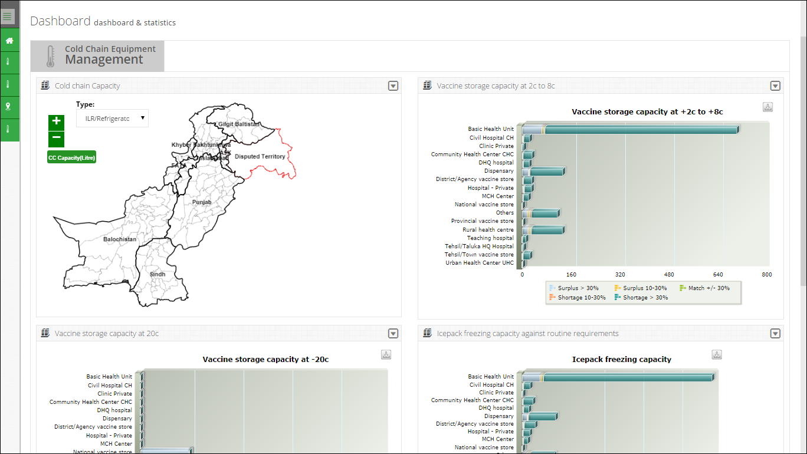

On the left side of the dashboard screen, the CCEM operator at the district level will see the following tabs:

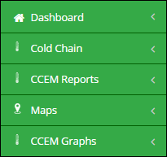

The CCEM District level operator screen includes the following features:

* **Dashboard**: User can view CCEM dashboard containing graphs, maps and analytical reports by using this tab.
* **CCEM**: enables the account user to report the cold chain asset’s status of the assigned warehouse/stores, which helps identify the working condition of the cold-chain machine.
* **CCEM Reports**: user can view the data analysis reports for cold chain equipment. Refer to the “CCEM Reports” section for details.
* **CCEM Graphs:** user can view CCEM graphs for analyzing data. Refer to the “CCEM Graphs” section for details.
* **Maps:** enables user to view the geographical map for Cold-chain capacity.

### **Dashboard**

Dashboard is a visual display of the most important information needed to achieve one or more objectives; consolidated and arranged on a single screen so the information can be monitored at a glance.

For CCEM users, dashboard for cold chain equipment management will be available. User can view the dashboard at the district level.

**Cold Chain Equipment Management**

Cold Chain Equipment Management dashboard allows users to view the cold chain capacity map by clicking on this tab.

* **Cold Chain Capacity**

This map shows a map highlighting the cold chain capacity of each district.

* **Vaccine storage capacity at +2c to +8c**

To show the storage capacity of vaccines at certain temperature range within selected health facilities.

* **Vaccine storage capacity at +20c**

To show the storage capacity of vaccines at 20 degrees centigrade within selected health facilities.

* **Icepack freezing capacity against routine requirements**

To show the icepack freezing capacity within selected health facilities.

**Cold Chain Capacity**

Cold Chain Capacity will be displayed through map.

The user can choose product from the drop-down menu.

* ILR/Refrigerators
* Cold Rooms



**Vaccine Storage Capacity at +2c to +8c**

Vaccine Storage Capacity at +2c to +8c will be displayed in the form of a bar graph. The user can view the health facilities list on the vertical axis while the capacity range is shown on the horizontal axis.



**Vaccine Storage Capacity at +20c**

Vaccine Storage Capacity at +20c will be displayed in the form of a bar graph. The user can view the health facilities list on the vertical axis while the capacity range is shown on the horizontal axis.



**Icepack freezing capacity against routine requirements**

Cold chain equipment management dashboard will also display icepack freezing capacity graph against routine requirements in the form of a bar graph. The user can view the health facilities list on the vertical axis while the capacity range is shown on the horizontal axis.



### **Cold Chain**

Click **Cold Chain** from the main menu to display a list of options.

****

**Add Refrigerator**

To add a new refrigerator:

1. Sign in to the User account.  
   User Home Page displays.
2. Under **CCEM**, click **Add Refrigerator.**  
   New/Add Refrigerator/Freezer/ILR Asset Page displays.
3. Specify the following filters:
   * **Asset ID/Equipment Code:** is an automatically generated unique identifier for the adjustment.
   * **Source of Supply:** select the supplier source from the list.
   * **Utilization:** select the utilization of the asset.
   * **Working Status**: select the status of the Asset from the list.
   * **Placed at**: Specify one of the following:

**Unallocated**: specifies that the asset is not allocated.

**Warehouse**: select the warehouse to place the asset.

* **Office**: In this drop-down, select the office to which you want to issue the asset. On selecting the **Office** level, specify the office location in the adjacent drop-down list. On selecting the location, the **Issue To** drop-down displays the relevant warehouse store names in the selected province. Select the required warehouse/store.
  + **Catalogue ID:** select the Catalogue ID from the list. You can also add a new catalogue ID by clicking **Add.** It will display a new window with following options:
* **Catalogue ID:** specify the Catalogue ID.
* **Make:** specify the make of the asset being added.
* **Model:** specify the model of the asset being added.
* **Asset Sub-Type**: Select asset sub-type from the list.
* **Dimensions**: Add the dimensions of the asset in feet.
* **Capacity:** Add the capacity of the asset in liters.
* **CFC Free Sticker:** select one of the options from Not Applicable, Yes and No.
  + **Serial No**.: Enter the asset’s serial number.
  + **Working Since (Year)**: Enter the year since the working of the asset.



1. Click **Save** to save the new asset.

**Search Refrigerator**

To search a refrigerator:

1. Sign in to the User account.  
   User Home Page displays.
2. Under **CCEM**, click **Search Refrigerator.**  
   Search Refrigerator/Freezer/ILR Asset Page displays.
3. Specify the following filters:
   * **Asset Sub-Type:** Select asset sub-type from the list.
   * **Source of Supply:** select the supplier source from the list.
   * **Working Status**: select the status of the Asset from the list.
   * **Asset ID/Equipment Code:** is an automatically generated unique identifier for the adjustment.
   * **Catalogue ID:** specify the Catalogue ID.
   * **Make:** specify the make of the asset being added.
   * **Model:** specify the model of the asset being added.
   * **Serial No**.: Enter the asset’s serial number.
   * **Gross Capacity From:** Add the gross capacity of the asset in liters.
   * **Gross Capacity to:** Add the gross capacity of the asset in liters.
   * **Working From:** Enter the year since the working of the asset.
   * **Working To:** Enter the year till the optimal working of the asset.
   * **CFC Free Sticker:** select one of the options from Not Applicable, Yes and No.
   * **Placed at**: Specify one of the following:

**Unallocated**: specifies that the asset is not allocated.

**Warehouse**: select the warehouse to place the asset.

* **Office**: In this drop-down, select the office to which you want to issue the asset. On selecting the **Office** level, specify the office location in the adjacent drop-down list. On selecting the location, the **Issue To** drop-down displays the relevant warehouse store names in the selected province. Select the required warehouse/store.
  + **Working Since (Year)**: Enter the year since the working of the asset.

1. Click **Search.**

****

1. **Report Type:** select the report type such as summary view or detail view.

**Add Vaccine Carriers**

To add a new vaccine carrier:

1. Sign in to the User account.  
   User Home Page displays.
2. Under **CCEM**, click **Add Vaccine Carriers.**  
   Add Vaccine Carriers Page displays.
3. Specify the following filters:
   * **Placed at**: Specify one of the following:

**Unallocated**: specifies that the asset is not allocated.

**Warehouse**: select the warehouse to place the asset.

* **Office**: In this drop-down, select the office to which you want to issue the asset. On selecting the **Office** level, specify the office location in the adjacent drop-down list. On selecting the location, the **Issue To** drop-down displays the relevant warehouse store names in the selected province. Select the required warehouse/store.
  + **Catalogue ID:** select the Catalogue ID from the list. You can also add a new catalogue ID by clicking **Add.** It will display a new window with following options:
* **Catalogue ID:** specify the Catalogue ID.
* **Make:** specify the make of the asset being added.
* **Model:** specify the model of the asset being added.
* **Dimensions**: Add the dimensions of the asset in feet.

1. Add **Total Available for Vaccination Activities** and click **Save.**



**Search Vaccine Carriers**

To search a vaccine carrier:

1. Sign in to the User account.  
   User Home Page displays.
2. Under **CCEM**, click **Search Vaccine Carriers.**  
   Vaccine Carrier Search Page displays.
3. Specify the following filters:
   1. **Catalogue ID:** specify the Catalogue ID.
   2. **Make:** specify the make of the asset being added.
   3. **Model:** specify the model of the asset being added.
   4. **Placed at**: Specify one of the following:

**Unallocated**: specifies that the asset is not allocated.

**Warehouse**: select the warehouse to place the asset.

* **Office**: In this drop-down, select the office to which you want to issue the asset. On selecting the **Office** level, specify the office location in the adjacent drop-down list. On selecting the location, the **Issue To** drop-down displays the relevant warehouse store names in the selected province. Select the required warehouse/store.

1. Click **Search.**



1. **Report Type:** select the report type such as summary view or detail view.

**Add Ice Packs**

To add ice packs:

1. Sign in to the User account.  
   User Home Page displays.
2. Under **CCEM**, click **Add Ice Packs.**  
   Add Ice Packs Page displays.
3. Specify the following filters:
   * **Placed at**: Specify one of the following:

**Unallocated**: specifies that the asset is not allocated.

**Warehouse**: select the warehouse to place the asset.

* **Office**: In this drop-down, select the office to which you want to issue the asset. On selecting the **Office** level, specify the office location in the adjacent drop-down list. On selecting the location, the **Issue To** drop-down displays the relevant warehouse store names in the selected province. Select the required warehouse/store.

1. Add **Quantity** before the ice pack size required to be added.
2. Click **Add.**



**Search Ice Pack**

To search an ice pack:

1. Sign in to the User account.  
   User Home Page displays.
2. Under **CCEM**, click **Search Ice Pack.**  
   Ice Pack Search Page displays.
3. Specify the following filters:
   1. **Make:** specify the make of the asset being added.
   2. **Model:** specify the model of the asset being added.
   3. **Placed at**: Specify one of the following:

**Unallocated**: specifies that the asset is not allocated.

**Warehouse**: select the warehouse to place the asset.

* **Office**: In this drop-down, select the office to which you want to issue the asset. On selecting the **Office** level, specify the office location in the adjacent drop-down list. On selecting the location, the **Issue To** drop-down displays the relevant warehouse store names in the selected province. Select the required warehouse/store.

1. Click **Search.**



1. **Report Type:** select the report type such as summary view or detail view.

**Add Cold Room**

To add a cold room:

1. Sign in to the User account.  
   User Home Page displays.
2. Under **CCEM**, click **Add Cold Room.**  
   Add Cold Room Page displays.
3. Specify the following filters:
   * **Asset ID/Equipment Code:** is an automatically generated unique identifier for the asset.
   * **Source of Supply:** select the supplier source from the list.
   * **Utilization:** select the utilization of the cold room.
   * **Working Status**: select the status of the cold room from the list.
   * **Placed at**: Specify one of the following:

**Unallocated**: specifies that the cold room is not allocated.

**Warehouse**: select the warehouse to place the cold room.

* **Office**: In this drop-down, select the office to which you want to issue the asset. On selecting the **Office** level, specify the office location in the adjacent drop-down list. On selecting the location, the **Issue To** drop-down displays the relevant warehouse store names in the selected province. Select the required warehouse/store.
  + **Type:** select the type of the cold room.
  + **Internal Storage Dimensions:** specify the storage dimensions of the cold room such as length, width and height.
* **Make:** specify the make of the cold room being added.
* **Model:** specify the model of the asset being added.
* **Internal gross volume:** specify in meters.
* **Net storage volume for vaccine/packs:** specify the volume in meters.
* **Year of Supply:** specify the year of supply for the cold room.
* **Number of cooling system:** specify the number of cooling systems in the cold room.
* **Number of phases:** select the number of phases.
* **Refrigerator gas type:** select the type of refrigerator gas.
* Specify if there is a **Voltage Stabilizer** or not.
* Specify if the cold room **has working backup generator**.
* **Temperature recording system:** select the temperature recording system from the list.
* **Type of recording system:** select the type of recording system.



1. Click **Save** to save the new cold room.

A new cold room would be added.

**Search Cold Room**

To search a cold room:

1. Sign in to the User account.  
   User Home Page displays.
2. Under **CCEM**, click **Search Cold Room.**  
   Cold Room Search Page displays.
3. Specify the following filters:

* **Type:** select the type of the cold room.
* **Working Status:** select the status of the cold room from the list.
* **Source of Supply:** select the supplier source from the list.
* **Number of cooling system:** specify the number of cooling systems in the cold room.
* **Asset ID/Equipment Code:** is an automatically generated unique identifier for the asset.
* Specify if there is a **Voltage Stabilizer** or not.
* **Make:** specify the make of the cold room being added.
* **Model:** specify the model of the asset being added.
* **Capacity From, Capacity to:** Add the capacity of the cold room.
* **Year of Supply From, to:** specify the year of supply for the cold room.
* **Placed at**: Specify one of the following:

**Unallocated**: specifies that the cold room is not allocated.

**Warehouse**: select the warehouse to place the cold room.

* **Office**: In this drop-down, select the office to which you want to issue the asset. On selecting the **Office** level, specify the office location in the adjacent drop-down list. On selecting the location, the **Issue To** drop-down displays the relevant warehouse store names in the selected province. Select the required warehouse/store.

1. Click **Search.**



1. **Report Type:** select the report type such as summary view or detail view.

**Add Voltage Regulator**

To add a voltage regulator:

1. Sign in to the User account.  
   User Home Page displays.
2. Under **CCEM**, click **Add Voltage Regulator.**  
   Add Voltage Regulator Page displays.
3. Specify the following filters:
   * **Placed at**: Specify one of the following:

**Unallocated**: specifies that the voltage regulator is not allocated.

**Warehouse**: select the warehouse to place the regulator.

* **Office**: In this drop-down, select the office to which you want to issue the asset. On selecting the **Office** level, specify the office location in the adjacent drop-down list. On selecting the location, the **Issue To** drop-down displays the relevant warehouse store names in the selected province. Select the required warehouse/store.

1. **Catalogue ID:** specify the Catalogue ID.
2. Add **Quantity** before the ice pack size required to be added.
3. Click **Add.**



1. User can also search a specific regulator from the list.

**Search Voltage Regulator**

To search a voltage regulator:

1. Sign in to the User account.  
   User Home Page displays.
2. Under **CCEM**, click **Search Voltage Regulator.**  
   Search Voltage Regulator Page displays.
3. **Catalogue ID:** specify the Catalogue ID.
4. **Make:** specify the make of the voltage regulator.
5. **Model:** specify the model of the voltage regulator.
6. Specify the following filters:
   * **Placed at**: Specify one of the following:

**Unallocated**: specifies that the voltage regulator is not allocated.

**Warehouse**: select the warehouse to place the regulator.

* **Office**: In this drop-down, select the office to which you want to issue the asset. On selecting the **Office** level, specify the office location in the adjacent drop-down list. On selecting the location, the **Issue To** drop-down displays the relevant warehouse store names in the selected province. Select the required warehouse/store.

1. **Catalogue ID:** specify the Catalogue ID.
2. Add **Quantity** before the ice pack size required to be added.
3. Click **Search.**



1. **Report Type:** select the report type such as summary view or detail view.

**Add Generator**

To add a new generator:

1. Sign in to the User account.  
   User Home Page displays.
2. Under **CCEM**, click **Add Generator.**  
   Add Generator Page displays.
3. Specify the following filters:
   * **Asset ID/Equipment Code:** is an automatically generated unique identifier for the adjustment.
   * **Source of Supply:** select the supplier source from the list.
   * **Utilization:** select the utilization of the asset.
   * **Working Status**: select the status of the Asset from the list.
   * **Placed at**: Specify one of the following:

**Unallocated**: specifies that the asset is not allocated.

**Warehouse**: select the warehouse to place the asset.

* **Office**: In this drop-down, select the office to which you want to issue the asset. On selecting the **Office** level, specify the office location in the adjacent drop-down list. On selecting the location, the **Issue To** drop-down displays the relevant warehouse store names in the selected province. Select the required warehouse/store.
  + **Make:** specify the make of the asset being added.
  + **Model:** specify the model of the asset being added.
  + **Serial No**.: Enter the asset’s serial number.
  + **Number of phases:** select the number of phases.
  + **Power Rating:** Enter the power rating of the generator.
  + **Power Source:** Select the power source of the generator.
  + Specify if the generator has an **Automatic Start Mechanism** or not.
  + **Year of Supply:** specify the year of supply for the generator.
  + **Use for:** select the use for the generator.



1. Click **Save** to save the new generator.

**Search Generator**

To search a generator:

1. Sign in to the User account.  
   User Home Page displays.
2. Under **CCEM**, click **Search Generator.**  
   Search Generator Page displays.
3. Specify the following filters:
   * **Working Status**: select the status of the Asset from the list.
   * **Source of Supply:** select the supplier source from the list.
   * **Asset ID/Equipment Code:** is an automatically generated unique identifier for the adjustment.
   * **Make:** specify the make of the asset being added.
   * **Model:** specify the model of the asset being added.
   * **Year of Supply from, to:** specify the year of supply for the generator.
   * **Placed at**: Specify one of the following:

**Unallocated**: specifies that the asset is not allocated.

**Warehouse**: select the warehouse to place the asset.

* **Office**: In this drop-down, select the office to which you want to issue the asset. On selecting the **Office** level, specify the office location in the adjacent drop-down list. On selecting the location, the **Issue To** drop-down displays the relevant warehouse store names in the selected province. Select the required warehouse/store.

1. Click **Search.**



1. **Report Type:** select the report type such as summary view or detail view.

**Add Transport**

To add a new transport:

1. Sign in to the User account.  
   User Home Page displays.
2. Under **CCEM**, click **Add Transport.**  
   Add Transport Page displays.
3. Specify the following filters:
   * **Asset ID/Equipment Code:** is an automatically generated unique identifier for the transport.
   * **Source of Supply:** select the supplier source from the list.
   * **Utilization:** select the utilization of the.
   * **Working Status**: select the status of the transport from the list.
   * **Placed at**: Specify one of the following:

**Unallocated**: specifies that the transport is not allocated.

**Warehouse**: select the warehouse to place the transport.

* **Office**: In this drop-down, select the office to which you want to issue the asset. On selecting the **Office** level, specify the office location in the adjacent drop-down list. On selecting the location, the **Issue To** drop-down displays the relevant warehouse store names in the selected province. Select the required warehouse/store.
  + **Transport Type:** select the transport type.
  + **Registration No.:** specify the registration number. This field is optional.
  + **Make:** specify the make of the transport being added.
  + **Model:** specify the model of the transport being added.
  + **Manufacture Year:** select the manufacture year of the transport.
  + **% use for EPI:** specify the percent use for EPI. This is an optional field.
  + **Fuel Type:** select the fuel type being used.



1. Click **Save** to save the new transport.

**Search Transport**

To search a transport:

1. Sign in to the User account.  
   User Home Page displays.
2. Under **CCEM**, click **Search Transport.**  
   Search Transport Page displays.
3. Specify the following filters:
   * **Transport Type:** select the transport type.
   * **Working Status**: select the status of the Asset from the list.
   * **Source of Supply:** select the supplier source from the list.
   * **Fuel Type:** select the fuel type being used.
   * **Registration No.:** specify the registration number. This field is optional.
   * **Make:** specify the make of the asset being added.
   * **Model:** specify the model of the asset being added.
   * **Manufacture Year from, to:** specify the year of manufacture for the tranport.
   * **Placed at**: Specify one of the following:

**Unallocated**: specifies that the asset is not allocated.

**Warehouse**: select the warehouse to place the asset.

* **Office**: In this drop-down, select the office to which you want to issue the asset. On selecting the **Office** level, specify the office location in the adjacent drop-down list. On selecting the location, the **Issue To** drop-down displays the relevant warehouse store names in the selected province. Select the required warehouse/store.

1. Click **Search.**



1. **Report Type:** select the report type such as summary view or detail view.

**Transfer Asset**

To transfer an Asset:

1. Sign in to the User account.  
   The User Home Page displays.
2. Click **Transfer Asset** under **CCEM**.  
   The Transfer Asset page displays.
3. In **From Office**, select the office.  
     
   **Office**: In this drop-down, select the office. On selecting the **Office** level, specify the office location in the adjacent drop-down list. On selecting the location, the drop-down displays the relevant warehouse store names in the selected province. Select the required warehouse/store.

The Asset’s details are displayed.



1. In **Transfer Quantity/Asset,** specify the quantity you want to transfer.



1. In **To Office,** specify the location that you want to transfer to.



1. Click **Transfer**.

### **Maps**

The LMIS also has the capability of generating easy to interpret maps with color codes. These interactive maps would be made available through the Government of Pakistan website and help in increasing the use of the existing information disseminates by Government of Pakistan through the web-based vLMIS by providing the information a more captivating approach to both promote the importance of supply chain and use of data in decision making.

This application is helpful for the health managers at all levels of administrative tiers for planning, identification of possible supply chain problems and new areas of improvements. In addition, GIS dashboards combined with other reports and graphs of vLMIS application give quick overview of monthly situation of commodities and reporting status. This is a good epidemiological tool to combine outputs of web-mapping application with other sources for data for research activities.

CCEM operators can view cold-chain capacity map by using the Maps tab from the main menu. Once the cold-chain indicator for which the map is to be viewed is selected, the user will be directed towards a page to select from various filters.

**Cold Chain Capacity Map**

This map shows the cold-chain capacity of each district within the selected province. User can see filter options such as Province/Region and Type of refrigerators or cold rooms to analyze the cold chain capacity rate for each district in the selected province based on the number of facilities in that district. The detailed information can be seen once the user clicks a particular district on the map.



### **CCEM Reports**

Refer to the “CCEM Reports” section of the user manual.

### **CCEM Graphs**

Refer to the “CCEM Graphs” section of the user manual.

